Mexican Polaca Chicken (Pollo a la Polaca) – recipe serves 6 to 8

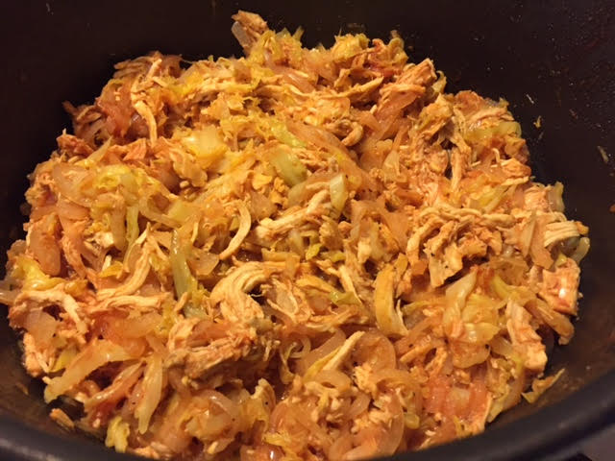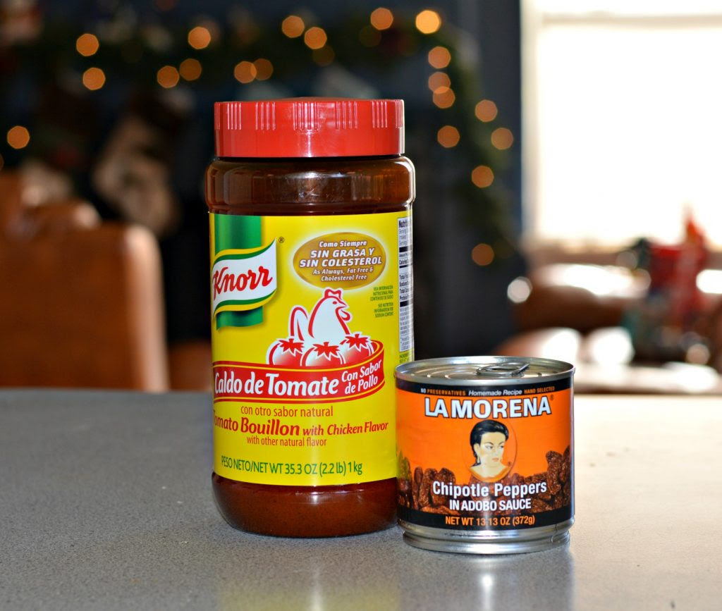

After Christmas, the celebration continues with this shredded chicken (roughly translated as Polish-woman chicken) served over tostadas. These are very popular in Mexico when celebrating Los Tres Reyes Magos day in January (Three Kings Day). Two of the principal ingredients that make this so delicious are Knorr® Tomato with Chicken Granulated Bouillon and La Morena® chipotle peppers in adobo. Both the Knorr® and the La Morena® names are well known in Mexico and are used in many different recipes. Both of these products are in Wal-Mart’s International aisle.

Ingredients:
2 boneless, skinless chicken breasts, cooked and shredded
½ head of cabbage, cut into thin slices
1 large white onion, cut into thin slices
3 teaspoons of Knorr® Tomato with Chicken Granulated Bouillon
1-2 La Morena® chipotle peppers in adobo
¾ cup of water
¾ cup of ketchup
Salt and pepper, to taste
2 tablespoons olive oil
2 tablespoons butter

Preparation:
Heat the oil and butter in a Dutch oven or other large pot over medium heat. Add the cabbage and the onion and cook through, until wilted. Add the chicken (I poach the chicken breasts in just enough water to cover for 40 minutes with 4 whole garlic cloves, a rib of celery cut in half, half an onion, some black pepper corns, some whole cumin seeds, a little Mexican oregano, a little dried thyme, salt and a couple of whole, dried chilis); season with salt and ground, black pepper.

Dissolve the bouillon into the water and add to the pot. Let cook for two minutes. Blend the chipotle peppers in adobo with the ketchup and add the pot. Let cook until most of the liquid has evaporated. Serve over tostadas (I like to fry my own tortillas) sprinkled with your favorite hot sauce and some crumbled Mexican white cheese.

