Madeira Pork: This is the sticky, spicy, sweet and tangy Portuguese barbeque-tasting pork that inspired Indian vindaloo

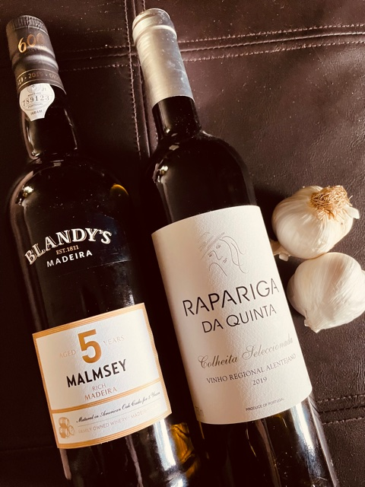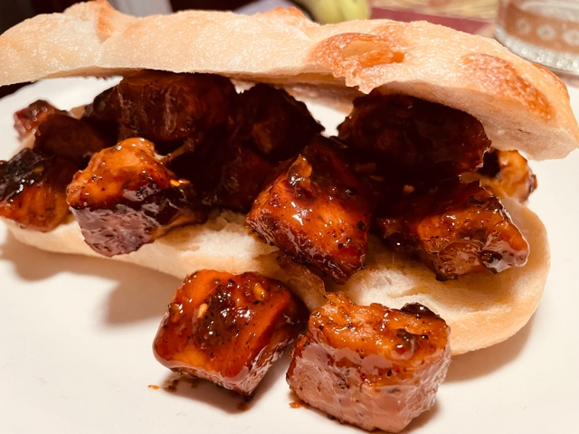

“Before there was Indian vindaloo, there was Portuguese carne vinha d’alhos,” said Albert Strumm in Milk Street magazine. Now a special occasion meal on the Portuguese island of Madeira, where it and its namesake fortified wine was created, this marinated pork dish was once sturdy sailors’ grub that would last through a long voyage. It apparently lasted all the way from Madeira to the colony of Goa, where lamb was substituted for pork to create vindaloo.

Though it’s common to marinate the pork for days, a Madeira native taught the editors of The Week in it’s May 14, 2021 issue a quicker version: “It’s delicious spooned onto a crispy roll, which quickly soaks up the sweet tangy sauce.“ That’s how it’s typically served in Madeira, but carne vinha d’alhos is also great with roasted or mashed potatoes.

Madeira Pork with Wine and Garlic (carne vinha d’alhos) - recipe serves two

Ingredients:
2½ pounds boneless pork, trimmed of fat and cut into 1- to 1½-inch chunks
1 cup dry, white wine (preferably a Portuguese variety – call around and you can find one)
1 cup Madeira wine, plus an additional ¼ cup
½ cup cider vinegar
5 bay leaves
3 - 6 medium garlic cloves, smashed and peeled
1½ teaspoons dried oregano
½ teaspoon red-pepper flakes, more to taste
3 – 4 whole cloves (optional, but good!)
Salt and ground, black pepper

Preparation:
In a large pot, stir together the pork, wine, the 1 cup Madeira, vinegar, bay leaves, garlic, oregano, pepper flakes, cloves and 1 teaspoon each of salt and black pepper. Cover and refrigerate for at least one hour or for up to 48 hours. I just mix it all up and put it in a quart-sized freezer bag in the refrigerator overnight.

When you are ready to cook, heat oven to 325°F with the rack in the lower-middle position. Pour the pork and its marinade into a Dutch oven or large oven-proof pot and set it, uncovered, on the stove over medium-high heat; bring it to a simmer, stirring occasionally. Cover, transfer to the oven, and cook until a skewer or knife inserted into the pork meets just a little resistance, about 1½ hours, stirring once halfway through.

Using a slotted spoon, transfer the pork and garlic to a small wire rack on a plate or to a colander, removing and discarding the bay leaves and cloves.

Add the additional ¼ cup Madeira to the pot, bring to a boil over medium-high heat and cook, stirring occasionally, until the mixture has reduced to about ½ cup of a nicely thickened glaze, 15 - 20 minutes; set aside. Remove and discard any large bits of fat on the exterior of the pork chunks that may remain.

In a 12-inch nonstick skillet over medium-high heat, heat a tablespoon of olive oil or any reserved pork fat until barely smoking. Add the pork and garlic pieces; sauté, stirring every 2 - 3 minutes, until well browned on all sides, 5 - 7 minutes.

Remove the skillet from the heat and add the reduced cooking-liquid glaze. Return to medium-high heat and continue to cook, stirring occasionally, until liquid has reduced and pork is lightly glazed and begins to sizzle, 3 - 5 minutes. Taste and season with salt and black pepper. Transfer to a serving tray so you and your guest may pile as much as you like onto crusty rolls. Enjoy!

