Latin Fried Chicken for Two

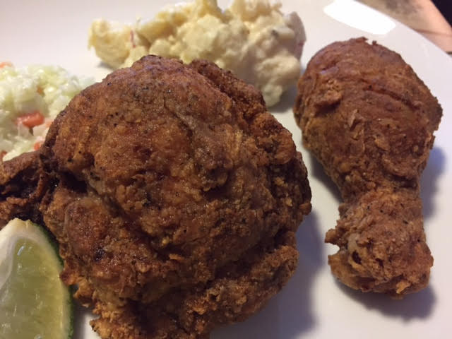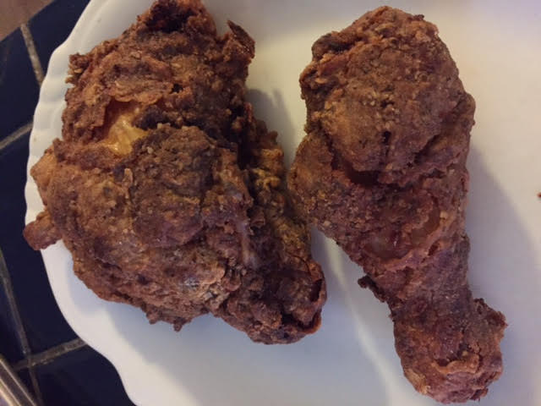

Ingredients:
1 pound bone-in, skin-on chicken pieces
Juice of 4 limes (about ¼ cup) and the zest of 1 lime (about 2 teaspoons)
6 cloves garlic, roughly chopped or sliced
1 tablespoon table salt, plus an additional teaspoon, divided
1 tablespoon ground cumin, plus an additional teaspoon, divided
2 tablespoons ground black pepper, divided
2 teaspoons smoked paprika
2 teaspoons oregano, preferably the Mexican variety
4 egg whites
1¼ cup all–purpose flour
¾ cup cornstarch
1 tablespoon granulated garlic powder
1 teaspoon baking powder
1 teaspoon ground white pepper
¼ teaspoon ground Cayanne pepper
Vegetable oil – for frying the chicken

Preparation:
In a measuring cup, mix together the limejuice, lime zest, garlic (you want it chopped in bigger bits so it can be easily wiped off later), 1 tablespoon table salt, 1 tablespoon cumin, 1 tablespoon ground black pepper, paprika and oregano. Marinate the chicken in it for two hours at room temperature (cut chicken breasts in half so they are roughly the same size as all other pieces). Do not leave it in for more than two hours or it will cause the meat to disintegrate.

After the chicken is marinated, wipe off the garlic. Dip it in the egg whites then dredge it through a mixture of 1¼ cup all–purpose flour and ¾ cup cornstarch mixed well with 1 tablespoon ground black pepper, 1 tablespoon granulated garlic powder, 1 teaspoon baking powder, 1 teaspoon ground white pepper, 1 teaspoon salt, 1 teaspoon ground cumin and ¼ teaspoon ground Cayanne pepper. Let the chicken rest after it is coated for at least 30 minutes and up to two hours.

Bring 2 inches of vegetable oil in a Dutch oven to 325° F. Fry the chicken, five pieces per batch, for about 15 minutes. Double check the meat is finished at 160° F. for breast meat and 175° F. for dark pieces with a meat thermometer. Allow to cool off a little bit before eating. It's really nice to squeeze a little fresh lime juice over the chicken before eating it!

