Classic Cuban Sandwiches

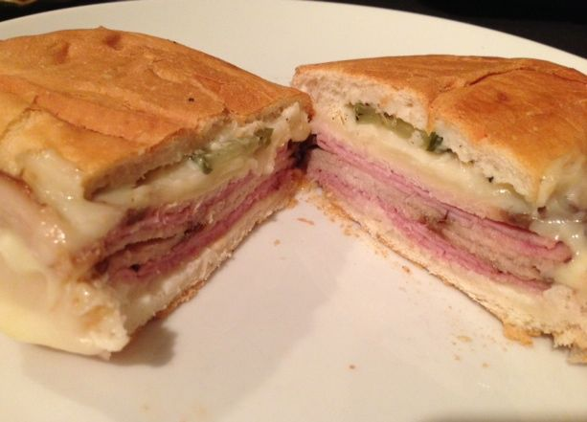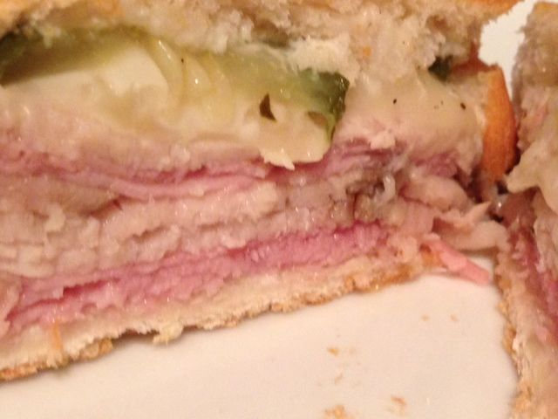

These are called “Cubanos” in Spanish, and I’ve also heard them referred to as “Medianoches” which means “Midnights” (because they are famous for being eaten late at night after the bars close in Havana).

Ingredients:
2, 6” sections French baguette or Italian long loaf
Mayonnaise to taste
Swiss cheese slices to taste (2 - 3 deli slices is good for one sandwich)
Deli-ham slices to taste (2 - 3 deli slices is good for one sandwich)
Pickle slices to taste
Thinly-sliced roast pork (check supermarket deli; 2 - 3 deli slices is good for one sandwich)
Salt & ground, black pepper

Preparation:
Preheat oven to 350° F.

Slice the bread in half length-wise and slather each interior side with mayo. Cover with the cheese, ham and pork slices. Top with pickles, add more cheese, if desired. Sprinkle to taste with salt and pepper.

Close the sandwich and wrap in aluminum foil. Place on a baking sheet, then place another baking sheet on top of the foil-wrapped sandwich(es). Press the top sheet down with a heavy skillet or foil-wrapped bricks.

Bake for 30 minutes.

