Cuban Sliders in a Casserole Dish – recipe makes 6, fat little sliders (3 per serving)

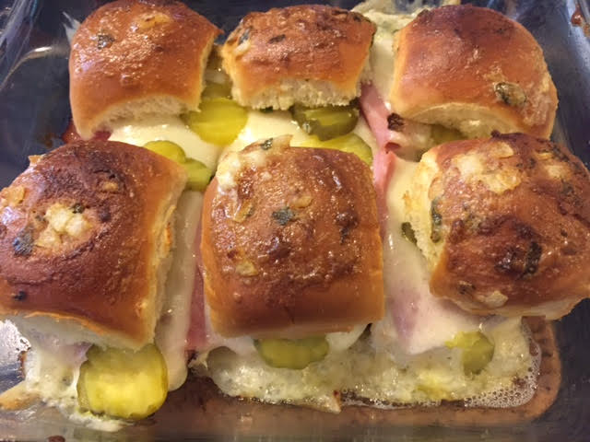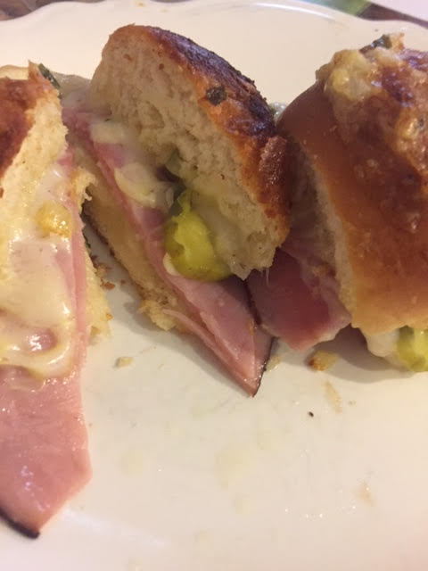

Ingredients:
6 sweet Hawaiian rolls, cut in half
6 slices Swiss cheese
6 slices deli ham
6 – 12 dill pickle slices (1 – 2 per slider, depending how big they are)
2 tablespoons mayonnaise
1½ teaspoons Dijon mustard
1 tablespoon butter, melted
1½ teaspoons onion, finely chopped
1 teaspoon fresh parsley, finely chopped
Salt and ground black pepper, to taste

Preparation:
Butter an 8” x 8” (2-quart) casserole dish and preheat your oven to 375˚ F. Place the bottom parts of the Hawaiian rolls in the casserole.

Whisk mayonnaise, mustard, melted butter, onion and parsley for the topping together and set aside 1 tablespoon; evenly spread the remaining onto the rolls in the dish.

Layer the ham, Swiss cheese and pickles, sprinkle with a little bit of salt and pepper, then top with the other halves of the rolls. Brush the tops of the rolls with the 1 tablespoon of mayo mixture that you set aside; cover with foil.

Bake for 15 minutes. Uncover and bake for another 5-10 minutes until the cheese has completely melted and the tops are browned and toasted.

