Bavarian Cabbage Salad with Bacon (recipe makes 4 servings)

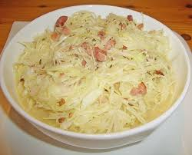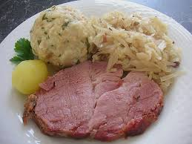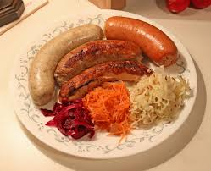

This zippy, fresh cabbage salad is a delicious alternative to sauerkraut. It’s traditional to serve it instead of sauerkraut with Bavarian roast pork (Schweinebraten). They also eat it with various German sausages.

Ingredients:
1 small or ½ a large green/white cabbage, washed and cut into fine strips
1½ teaspoons salt
8 slices bacon or 2 ounces pancetta
1 small onion, peeled and finely chopped
3 tablespoons white-wine vinegar
1 cup vegetable broth
1½ teaspoons caraway seeds, whole or ground
1 teaspoon spicy mustard, not American yellow mustard (grainy European-style)
4 tablespoons vegetable oil
Additional salt and ground, black pepper, to taste

Preparation:
Mix the sliced cabbage with the 1½ teaspoons salt. Cover and let it sit at room temperature until the other ingredients are prepared.

Dice the bacon and fry it with gentle heat, with frequent turning until the grease escapes (see notes below). Add the chopped onions and fry them until opaque, stirring occasionally. Add the vinegar and the broth and let it boil, stirring until the pan is deglazed. Mix in the caraway, mustard and oil.

Toss the cabbage thoroughly with this marinade, cover and let sit at room temperature for about 3 hours (see notes below). Season the salad with plenty of pepper and salt.

Notes:
The authentic Bavarian recipe calls for not browning the bacon at all. But screw that! I like mine nice and crispy! Also, the recipe that I translated from German into English calls for letting the salad marinate for “about three hours,” but it tastes wonderful if you just let it marinate for an hour. And I like to put it in a gallon Ziploc and chill it in the fridge while it marinates, turning the bag every so often.

