Classic Boeuf Bourguignon for Two

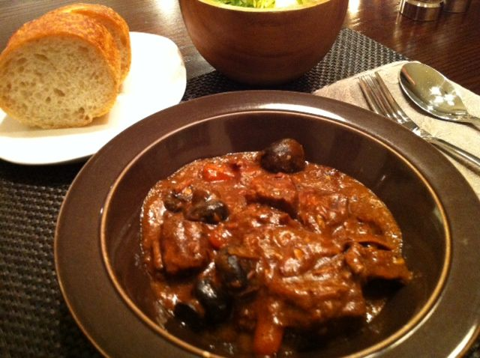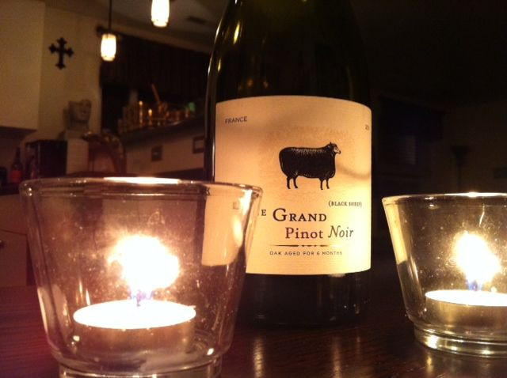

This recipe closely resembles the Boeuf Bourguignon that I had in Paris at the George V restaurant on the Champs Élysées boulevard. It calls for bigger cuts of quality beef instead of cubed “beef stew” meat, and good-quality red wine (see notes).

Ingredients:
¾ cup very thin carrots, cut into 1” pieces
¾ pound beef rump roast, cut into big, 2”– 3” cubed hunks
4 ounces (¼ of a 16-ounce bag) frozen pearl onions
4 ounces fresh, whole button mushrooms (crimini mushrooms work great)
1 dried bay leaf
1 tablespoon all-purpose flour
1 tablespoon unsalted butter, softened to room temperature
1½ teaspoons tomato paste
Salt and ground, black pepper, to taste

For the Sauce
½ of a 10-ounce can condensed beef consommé
¼ cup dry, red wine (I use Pinot Noir or a nice cabernet sauvignon - see notes below)
1 - 2 cloves fresh garlic - finely chopped/minced
1½ teaspoons Dijon mustard
1 teaspoon beef and/or chicken bouillon
½ teaspoon cornstarch
½ teaspoon all-purpose flour
½ teaspoon onion powder
½ teaspoon granulated garlic powder
½ teaspoon ground, black pepper
½ teaspoon sugar
¼ teaspoon olive oil
¼ teaspoon molasses
¼ teaspoon Worcestershire sauce

Preparation:
Layer the carrots, beef chunks, onions and mushrooms in a 2-quart, slow-cooker with removable crockery in the order listed above. In a 16-ounce measuring cup, whisk together the sauce ingredients. Pour the mixture over the contents in the slow cooker, then set the removable pot in the fridge overnight.

The next day, cook on the low-heat setting for ten hours (see notes below). You can of course do this on low heat all day on the stove.

Thirty minutes before serving, shut off the slow-cooker and place the contents in a suitably-sized saucepan; fish out the bay leaf. Thoroughly cream/fold together the softened butter, tomato paste and flour in a small bowl, then mix it well into the pot. Let the pot come to a boil, then reduce the heat to medium-low and simmer until it has reduced to your liking (in Paris, it was quite thick).

Serve with crusty French bread, a green salad and the rest of the bottle of wine.

Notes:
Don’t use Ernest & Julio Gallo “Burgundy” wine! I start the pot on low between 7 and 8 a.m., and it’s ready by 6 p.m.

