Russian Noodles & Cabbage – recipe makes 4 servings

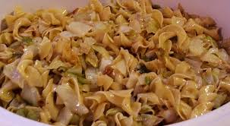

This is a recipe that I got from one of my Russian language instructors while I was learning Russian in the army in 1983.

Ingredients:
½ pound pasta, preferably the bowtie type
½ a small head of cabbage, thinly sliced
1 medium white onion, thinly sliced
2 tablespoons butter
Salt and ground, black pepper, to taste

Preparation:
Cook the pasta according to package directions.

Meanwhile, melt the butter in a large pot over medium heat. Sauté the onions and cabbage in the butter until opaque.

Drain the pasta and combine it in the pot with the sautéed onions and cabbage. Season, to taste, with salt and ground black pepper.

