Russian “Cutlets” (котлеты) – recipe makes 4

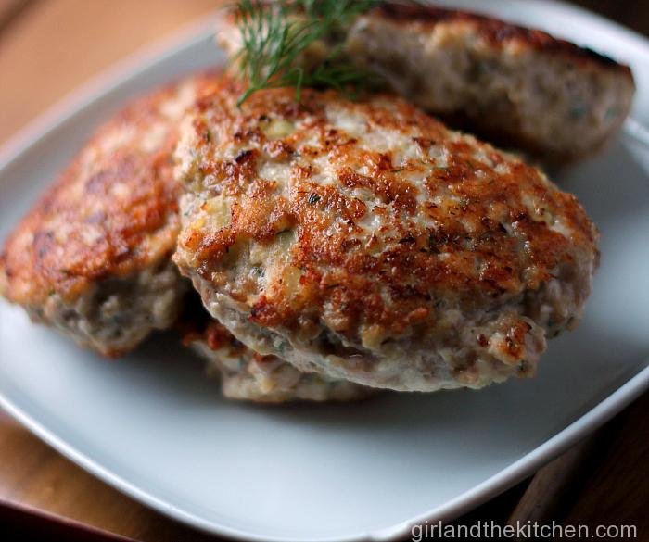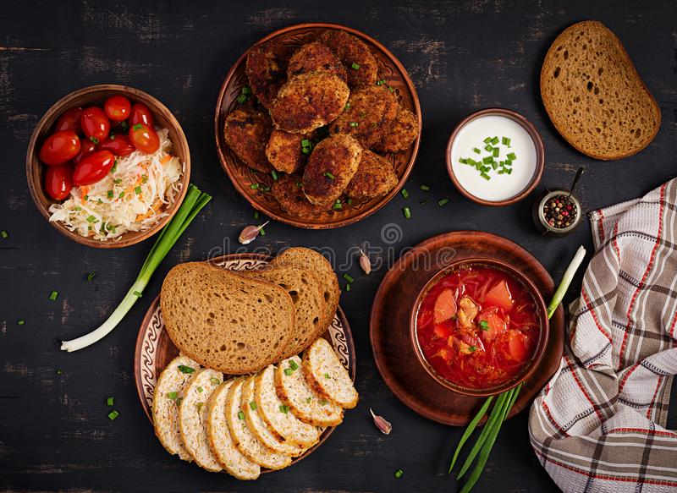

Being born of Soviet-era deprivation when meat was a scarce luxury, the history of this simple recipe, which remains a favorite of Russians today, is somewhat mysterious and even a little paradoxical. I’m thinking that it was probably just a way for the Soviet people to stretch out whatever meager quantities of meat their government’s inept, communist economy gave them with the addition of the starch and other fillers.

Ingredients:
1 pound ground meat – any kind; beef, chicken, turkey, lamb, whatever you have on hand
1 small onion, or ½ of a large one, very finely minced (see notes, below)
A few cloves of garlic, finally minced
½ cup breadcrumbs, more or less (see notes, below)
1 egg, beaten
1 teaspoon salt
1 teaspoon ground, black pepper
1 teaspoon ground/dried mixed herbs of choice, like parsley, dill, oregano, thyme
Oil for frying meat patties

Preparation:
Mix all the ingredients together, except for the oil, of course, and form into four oval patties (see notes, below).

Bring just enough oil to cover the bottom of a 12” frying pan up to heat and fry the patties for about 4 - 5 minutes on each side, until browned and crispy.

Serve with boiled potatoes, crusty bread or with chopped tomatoes and cucumbers dressed with a simple vinaigrette. Really, one just serves these with anything that is on hand for a side dish.

Notes:
In all versions of the traditional recipe, the onions are so finely minced that you should really give them a few good whirls in a food processor, almost until they are soupy. Also, most versions of the traditional recipe call for using two slices of bread, soaked in milk and thoroughly squeezed out - others just call for dried breadcrumbs. Some recipes call for dredging the patties in some more breadcrumbs before frying. This appears to be totally optional.

