The Caesar Cocktail

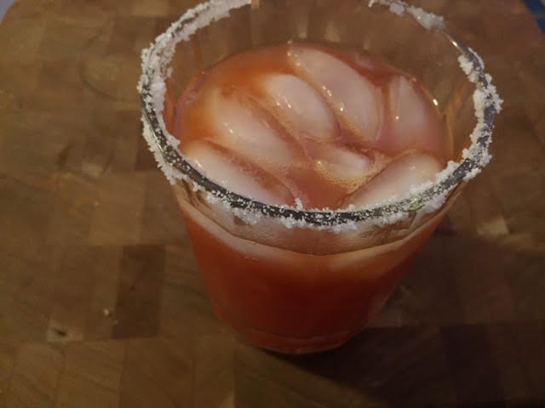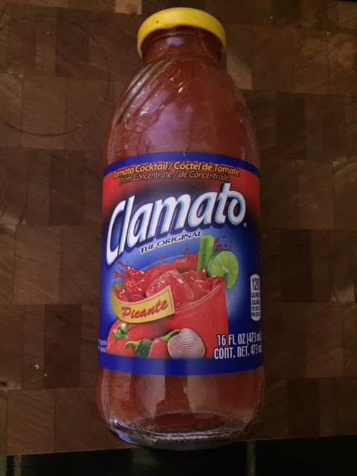

This simple, tasty cocktail is like a very mild Bloody Mary. No clam taste at all!

Ingredients per Individual Cocktail:
4 ounces Clamato
2 ounces vodka
5 dashes Tobasco sauce
3 dashes Worcestershire sauce
1 teaspoon lemon juice
Salt

Preparation:
Fill a regular sized cocktail shaker ¼ of the way with ice (per drink). Shake all the ingredients well, open the top of the shaker and pour everything (ice included) into a rocks glass that you have rimmed with salt. Enjoy!

