“Party in My Pantry” cocktail recipe

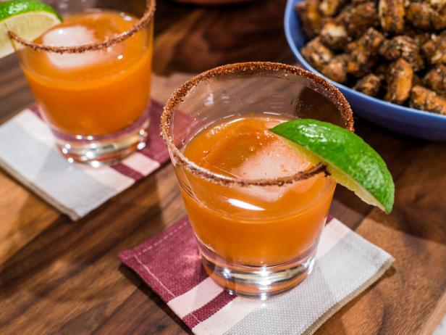

This is Geoffrey Zakarian’s crazy, but delicious “Party in My Pantry” cocktail recipe with barbeque sauce and other pantry staples! It sounds crazy, but it works.

Ingredients per Cocktail:
For the Chipotle-Sugar (to dip the rim of the glass in – see my note):
- 2 tablespoons chipotle chili powder
- 2 tablespoons sugar
- 1 lime wedge

For the Cocktail:
- 1½ ounces tequila, such as Casamigos Anejo Tequila
- 1 ounce sweet BBQ sauce
- ¾ ounce fresh limejuice (see my note below)
- ½ ounce clover honey (see my note below)
- ¼ ounce maple syrup

- Preparation:
- For the chipotle-sugar: On a plate or in a bowl, mix together the chipotle powder and sugar until combined. Rub a lime wedge on half of the rim of a glass, then dip the rim into the chipotle/sugar mix. (See my note below.)

- For the cocktail: Add the tequila, BBQ sauce, limejuice, honey and maple syrup to a mixing tin. Add a large ice cube and shake vigorously (I found that the honey really gets solidified by the cold of the ice, so I mix everything up well before subjecting it to the icy cocktail shaker). Place a fresh ice cube in the prepared glass and strain the drink over the ice.

Note:
I don’t have chipotle chili powder, so I just use regular, dark chili powder. I also use whatever kind of honey I have in the pantry at any given time. Also, I use bottled limejuice and it turns out great!

