Yorkshire Pudding – recipe makes 12

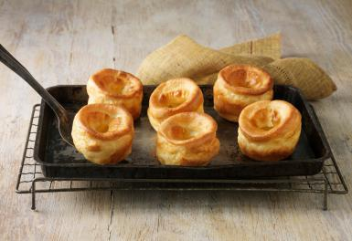

Yorkshire pudding was invented by poor English people to trick one’s stomach into thinking that one is eating way more meat than would have been available to the lower class back in the day. So because these are traditionally eaten with roast beef, get a roast in the oven before you make them.

Ingredients:
5 large eggs
1 cup half-and-half
1 cup all-purpose flour
Salt
Roast beef drippings, lard or vegetable oil – enough to fill 12 muffin tins about ½ of the way up

Preparation:
Make the batter before removing the beef from the oven: Combine the eggs and half-and-half in a bowl and whisk until they're totally combined. Throw the flour and 2 teaspoons salt into a sifter and sift them straight into the bowl. Whisk until it's nice and smooth, then refrigerate until the beef is ready.

After the beef is removed from the pan, increase the oven temperature to 450° F. Use a slotted spoon to remove any solids from the drippings. Pour the remaining drippings into a separate container.

Pour a small amount (about ½ teaspoon or so) of the drippings into each cup of a standard muffin pan and place the pan in the hot oven for a couple of minutes, or until just before the drippings begin to smoke.

Carefully remove the pan from the oven and immediately fill the muffin cups about ½ to ⅔ full. Bake 13 to 14 minutes, or until they've popped about as much as they can pop. Serve them in a basket with a pretty napkin right next to the beef.

