Welsh Pasties

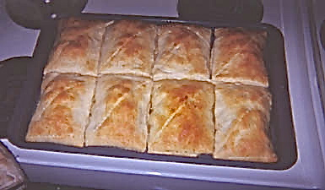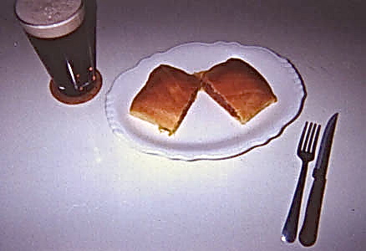

These are normally made with semi-circular pastry shells (as in my Cornish pasty recipe), but I add a personal touch to this venerable dish from Wales by using square crescent-roll dough and it tastes super!

Ingredients:
1, 15-ounce can any commercial brand of corned beef hash
1, 8-ounce tube any commercial brand of crescent-roll dough
1 very small onion (about 2 ounces), minced or finely diced
½ teaspoon salt
¼ teaspoon ground, black pepper
1 tablespoon vegetable oil

Preparation:
Preheat oven to at 350° F.

In a medium skillet, heat oil over medium heat. Season onions with a dash of salt and pepper; sauté onions until transparent. Lower heat and add the corned beef hash. Heat through just until it's hot (be careful not to brown it to a crisp at all!). Add salt and pepper, set aside.

Unroll the crescent rolls, dividing into equal rectangular sections (most brands come in containers of 8 perforated, triangular sections which are easy to make into 4 rectangular sections each package by keeping two triangles together for each rectangle and pinching the perforated dough closed between each pair).
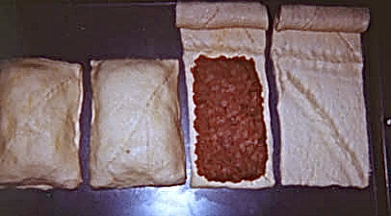

Line up rectangular sections of the dough on an ungreased baking sheet at least 11" x 17" in dimension. Carefully spoon one-quarter of the warmed corn beef hash on each pastry rectangle, taking care to keep as much as possible away from the outer edges of the inside of the dough (it'll be hard to pinch together the edges to seal it up otherwise).

Next, blanket each with a second rectangular section of dough and pinch the edges of each side together to seal the meat contents in good. Bake on the center oven wrack for about 35 minutes, or until dark golden brown.

Note:
I use Pillsbury low-fat crescent rolls, the reduced-fat corned beef hash, and it all works wonderfully well together.

HRH The Prince of Wales is officially Charles Philip Arthur George Mountbatten-Windsor, Heir Apparent to the respective thrones of the United Kingdom.

