Welsh Cakes (recipes makes about 18)

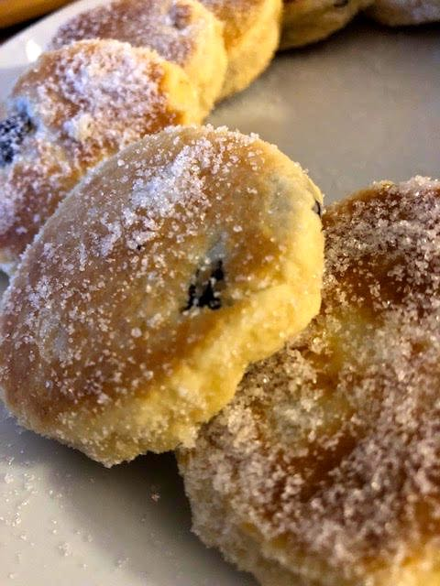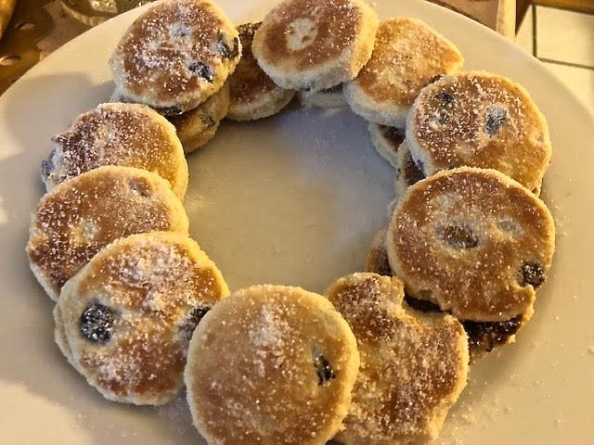

Served warm with just a little butter on top, these delectable little pancakes are also known as “bakestones” in Wales because they are traditionally cooked on a bakestone, which is a cast iron griddle about ½“ thick that’s placed on a fire or cooker top; on rare occasions, people may refer to them as “griddle scones.”

Ingredients:
1¾ cups all-purpose flour
2½ teaspoons baking powder (or just use 1¾ cups self-rising flour and omit it)
¾ teaspoon salt
½ cup (1 stick) butter, melted
½ cup sugar, plus spread some more out on a plate to lightly coat the fried cakes
¼ cup currants or raisins
1 large egg, beaten
2 tablespoons milk (yep, just two)

Preparation:
Thoroughly mix together the flour, baking powder, salt, sugar and currants/raisins. Mix in the butter, egg and milk – it should turn out to be fairly stiff dough.

Roll the dough out flat to about ¼“ thickness (it works well to do it on wax paper – you don’t have to flour the surface at all to roll out this buttery dough). Using an upside down drinking glass or circular cookie cutter about 2½“ – 3” in diameter, cut out as many rounds as you can; gather up the leftover trimmings, knead them together into a ball and roll it out to about ¼“ thickness to cut out more cake rounds. Repeat as necessary until nearly all the dough is used up.

Cook on a griddle or large frying pan greased with more butter over medium heat about 3 minutes on each side, or until golden brown. Dredge both sides of the hot cakes in sugar and serve warm with more butter on top (I think they taste great without extra butter on them, though). They’re pretty good served cold, too!

