Easy English Pork Pies
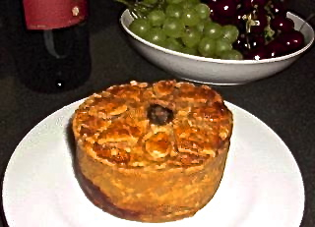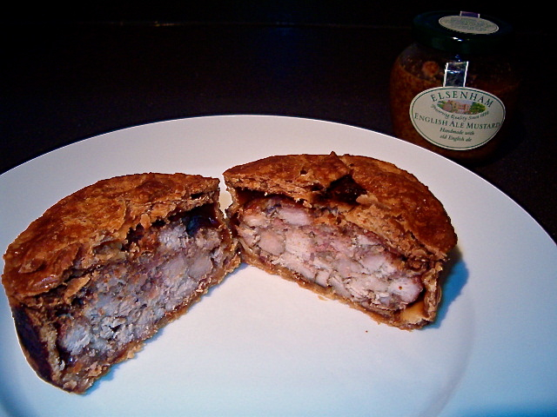

Widely enjoyed throughout Britain, but most popular in the English Midlands, pork pies are customarily eaten cold in the United Kingdom. Many out there might think this to be strange, but no one should knock it until he or she tries it! I have never been fond at all of eating any meat dish cold; I am not one to eat green salads containing meat, cold pizza in the morning or cold, fried chicken at picnics. But these are surprisingly delightful served cold, and I would never dream of warming them up to eat - with the flaky, sauce-infused crust, the tender, delicate texture of the slow-simmered pork, and the savory succulence of the crispy-cooked bacon inside, these are, in fact, the perfect picnic main course destined by fate itself to be happily consumed at or below room temperature.

The most popular of the traditional, English pork-pie recipes, such as Melton Mowbray, are quite involved and require a number of steps in the cooking process that might put off even the most intrepid of adventurous, American foodies. But I have conquered the complications of making authentic, English pork pies in America with this easy recipe.

Ingredients:
2, 9" short crusts - the usual and ordinary kind of pastry used for baking pies
12 to 16 ounces (between approximately .69 pound and 1 pound) of lean pork; center-loin meat works perfectly, cut into ¾”cubes
1, 8-ounce package bacon, thinly sliced and chopped into bits (see notes below)
1 teaspoon sage
½ teaspoon allspice
¼ teaspoon salt
Ground, black pepper, to taste
1 egg (for glazing the pie tops)
½ pint of jellied pork stock or aspic - but it's easy enough instead to use a mixture of commercial, powdered gelatin and pork bouillon (see notes below)

Equipment: A small kitchen funnel and two, small spring-form baking tins approximately 4" in diameter and 2" in depth. These are commonly available at little cost - I got a non-stick (Teflon-coated) set of two at a local house-wares store for only $12.99.

Preparation:
Preheat oven to 350° F.

Rinse off the raw, cubed pork well, then mix it in a bowl with the raw bacon pieces, the sage, allspice, salt & pepper. Cover the meat mixture and set it aside while you prepare the pie tins.

Roll out the piecrusts. Take the bottom out of each spring-form pie tin and cut out a pastry circle to lay down in each tin. Before laying down the bottom circle of pastry in each spring-form tin, reassemble each tin, then grease the insides of them well (at least spray them well with non-stick cooking spray, even if you are using Teflon-coated tins).

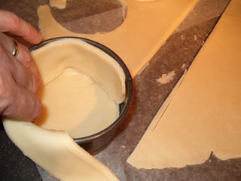

Cut out two long, wide strips for each spring-form tin, the length and width of the dimensions of the interior wall of the tins (put one of the tins on its side and roll it out along the dough to size the strips accurately); place each strip in the interior of each spring-form tin, and mold the strips down well to the dough on the tin bottoms with your fingers.

Evenly divide the meat mixture in two and carefully fill each spring-form pastry case with half; press the meat down in the tins really well, and you shouldn't have any left over (if you bought up to a whole pound of pork, you might have a small bit leftover, though)! Trim off excess pastry from each tin that is above the level that the meat reaches.

Press the remaining pastry into a round to form a lid/top for each pie. Place the lid on each, dampen the edges and crimp to seal. Using your small funnel tip as a stencil, cut a hole in the center of each pastry lid to allow steam to escape (it's easiest to punch the hole in the center of each pie-top pastry round before actually placing on the pies).

Use any excess to decorate (three diamond-shaped lozenges around the vent hole are traditional). Brush with beaten egg (or butter) to provide a glaze. Bake for 2½ hours.

Remove from the oven and allow to cool. Remove the pies from the spring-form tins when cool.

Now, this next step might strike some Americans as completely strange, unorthodox and, at the very least, quite odd. But it seems to be central to the Melton-Mowbray style of English recipes for making pork pie (it's as eccentrically English as can be).

If you are actually able to get your hands on eight ounces of jellied pork stock (or aspic) in the U.S., congratulations! Make sure it is cut up into small cubes and heated to the melting point - pour as directed next. Otherwise, use the hot Knox gelatin-bouillon mixture described in my notes below. Pour it into the pies through the steam-vent holes using your funnel (just add a little bit at a time so it doesn't overflow out all over your nice, flaky pastry tops). You'll probably only end up using about three ounces of it in each pie - you'll know you've gone too far if it starts leaking out the bottom of your pastries; just wipe them up nice and dry with a clean paper towel if that happens.

Chill for at least four hours before serving. Makes two lovely, little pork pies. Serve with spicy English mustard on the side for dipping.

Notes:
The jellied stock is traditionally made from pig "trotters" (their feet). As a wonderful and tasty substitute for the traditional, jellied pork stock, use one envelope of Knox brand powdered gelatin, which is widely available in most U.S. grocery stores. What you do is sprinkle the powdered gelatin over ¼ cup of very cold water, then add 1¾ cups boiling water; stir the mixture well and add any commercial-brand of ham or pork-flavored bouillon to it (using the measurements required by your bouillon's instructions for the two cups of liquid mixture that this method produces). Make sure you stir it until the bouillon is dissolved well. The two pies that this recipe makes will not require all this gelatin/bouillon mix, so you will have to discard what you do not use or save it, if you can, for another time. Pork bouillon in cube form is not widely available in regular American grocery stores, but it is quite common in Asian and Latino food markets (Goya brand is usually available in Latin-American shops). I use "Superior Touch" brand ham base bouillon which is widely available throughout the U.S. in the big, commercial supermarkets.

Unsmoked bacon is what this recipe traditionally calls for, but it's really hard to find in U.S. supermarkets. But any common American brand, like Oscar Mayer, works just fine (in fact, these taste absolutely fabulous when made with smoked bacon). Try to trim as much of the white fat off it as you can to use the leanest possible pieces (I use a pair of kitchen sheers). This reduces the total weight of the bacon used to a quantity appropriate for making just enough filling for the two pies. Doing this also significantly reduces the fat content and liquid that ends up in the pie shells when they are baked.

Commercial pie-crust dough is widely sold in most American supermarkets in the refrigerated aisle. It holds up surprisingly well to the long baking time required in this recipe to completely cook the raw-meat filling through.

