Jeff’s “Toad-in-the-Hole” Sausage Roll Recipe – (makes 4)

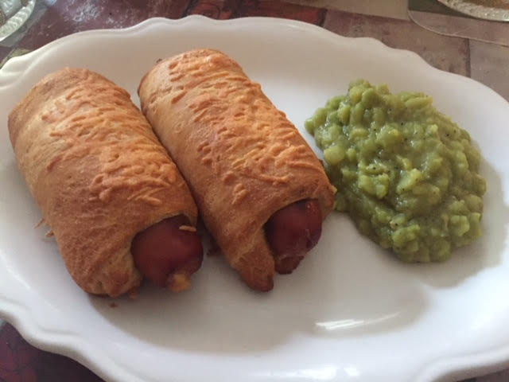

I think I’ve come up with the best of two great British dishes in one with this recipe! English toad-in–the–hole and sausage rolls are both wonderful old dishes that are probably remote ancestors of the American classic, “pig–in–a–blanket.“ English sausage rolls are customarily made with puff pastry and loose sausage meat for the filling (see my recipe for those). Authentic toad-in–the–hole is basically a large, shallow, bready pastry with sausages bacon in it. My quest to make traditional English sausage rolls leaner and healthier resulted in this Americanized version which turned out to be more of a cross between English toe–in–the–hole and traditional English sausage rolls.

This recipe is more simple to prepare then either sausage rolls or toad–in–the–hole, and I think it’s even more delicious than original English sausage rolls.

Ingredients:
4 smoked sausages, or 1 pound smoked kielbasa–style sausage cut into 4 even sections
1 8-ounce tube of ready–to–bake crescent rolls
An ounce or so of shredded Cheddar cheese

Preparation:
Preheat your oven to at 375° F.

Broil or braise the sausages to brown them a little. Crack open the tube of crescent rolls, dividing the dough into four equal rectangular sections (most brands in the refrigerated tubes come in eight perforated, triangular sections which are easy enough to make into for rectangles by keeping two of the triangular sections together). Roll up a piece of sausage in each rectangular section of dough. Sprinkle some shredded cheddar over each roll, then bake, seam-side down, for 12 to 15 minutes, or until golden brown.

