Frazzled Beef for Two

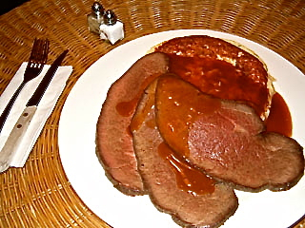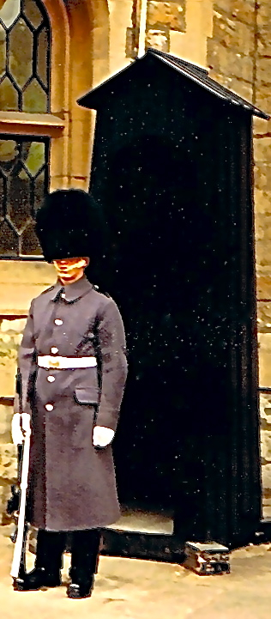

What on earth is this? This is also called "frizzled beef" because of the sound it makes while cooking. It's a hearty meal that is quick to prepare from roast-beef dinner leftovers. Originally, the fat used in this recipe would have been beef drippings (which are eaten over toast sometimes as a favorite snack called "drippings on toast"). But we don't want to make it too terribly bad for our hearts, so I recommend using healthy cooking oil instead.

Ingredients:
6 slices of cold beef (about 1 ounce each – 3 per serving)
4 to 6 tablespoons vegetable oil
¼ cup finely chopped or minced onion (optional)
2 to 4 cups cold mashed ("smashed") potatoes
Salt and ground, black pepper to taste
Brown gravy, for dressing the plates

Preparation:
Form two patties about 1" thick each in one or two pans with your chilled whipped potatoes. If you want to use the onion, heat some oil in a frying pan and fry the chopped onion until soft and nicely caramelized. Mix the onions into the cold potatoes before forming your patties (see notes below). Preheat a little oil in a very large skillet or in two smaller pans (it works best for me if I use two and spray them first with some commercial brand of non-stick cooking spray); cook the patties on both sides over medium-low heat until golden brown. Remove the patties from the skillet(s) on to two serving dishes and keep them warm in the oven. A good trick for flipping/removing the patties is to simply hold a plate on the hot skillet and turn it upside down onto the plate (to brown the other side, the patties will slide easily enough with a spatula off the plate and back into the pan).

Next, add a little extra oil to the pan(s) and lightly fry the beef slices on both sides to heat them through. Arrange the beef on top of the browned potato pancakes and serve with enough thick, brown gravy to suit your taste. Season with salt and pepper to taste.

I like to arrange the potato patties on each plate so that they are off center from the beef (this insures that you can cover everything well with gravy). Serve with green beans or some other cooked green vegetable.

Notes:
Using the warm, chopped onion bits makes this recipe more authentic, but it also makes it a little more difficult to form the patties because the onion will warm them up and they can get soft and unmanageable then - it's best to fry the onions, mix them into the whipped potatoes, then let the potatoes and onions chill back down in the fridge for an hour or so before making the patties! You can get pre-made whipped potatoes in most supermarkets, either frozen or ready-to-serve in the refrigerated section. You can also pick up sliced roast beef to make this recipe in any supermarket's deli section.

