English Sausage & Cabbage For Two

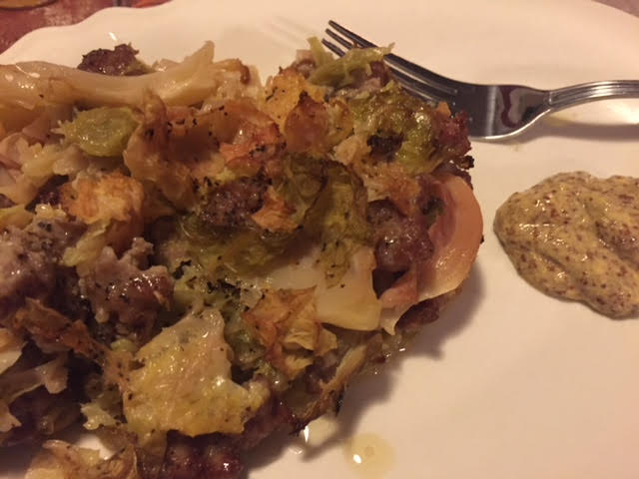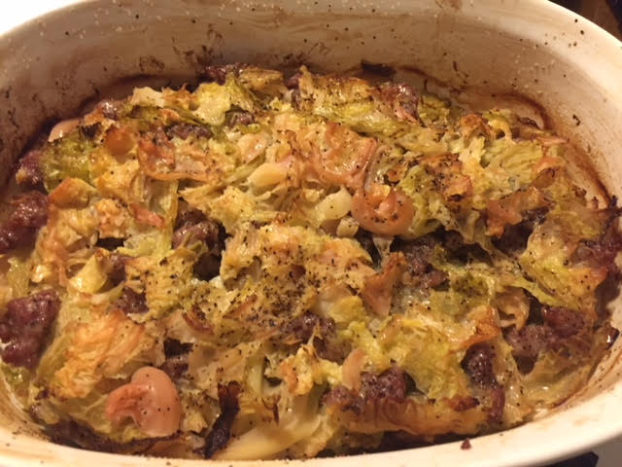

This recipe is an adaptation of one created by Tamasin Day-Lewis, a star of British cookery. This casserole recipe, which she credits to the British food writer Jane Grigson, has just four ingredients: sausage, cabbage, butter and pepper. But, after two and a half hours in the oven, it emerges mysterious and succulent.

Ingredients:

½ - ¾ pound fresh pork sausages or bulk pork sausage
1 very small or half a green or Savoy cabbage (about 1 pound), cored and thickly shredded
3 tablespoons unsalted butter
Salt and ground, black pepper
English mustard, for serving

Preparation:
Heat oven to 300° F. Bring a large pot of salted water to a boil and butter a 2½-quart baking dish with a lid. If using sausage links, remove casings and discard them.

Place cabbage in boiling water, cover, and let water come back to the boil. Uncover and boil for 3 minutes. Drain cabbage in a colander and run cold water over it to stop cooking.

Put ⅓ of the cabbage in the buttered dish and cover with ½ the meat – just scatter pinches of the raw sausage evenly over the cabbage. Sprinkle with salt and pepper and dot with butter (I like to tuck a few new potatoes in at this point). Repeat, ending with a final layer of cabbage, and dot top with butter.

Cover dish tightly with a layer of parchment paper, then top with a lid or a layer of aluminum foil. Cook for about 2½ hours, until cabbage is soft and sweet, and top is lightly browned. After 2 hours, uncover the dish; if there is a lot of liquid in the bottom, leave uncovered for the rest of the cooking time. If not, re-cover and finish cooking.

