English Beef Stew

Irish Stew is made with tasty, tender lamb and is pretty darned good. But here's a recipe for traditional beef stew made the good old English way, but in a slow-cooker. If you don't have an electric slow-cooker, then you have to do it the old-fashioned way by cooking it for the prescribed amount of time on very low heat at a slow simmer, constantly tending the pot and stirring it to insure the stew doesn't burn.

Ingredients:
½ pound beef chuck or stew meat, cut into 1" cubes
¼ cup all-purpose flour
1 teaspoon salt
½ teaspoon ground, black pepper
½ teaspoon mild paprika
1/3 cup beef broth or water
1 tablespoon Worcestershire sauce
1 clove garlic, crushed
1 small bay leaf
1 carrot, sliced in ¼“ pieces
1 waxy potato (like Yukon Gold or red), diced into 1⁄2" cubes
1 small onion (about 2 ounces) finely chopped
1 rib celery, sliced in ¼” pieces
2½ ounces frozen peas (optional, but very tasty)

Preparation:
Wash meat and pat dry with paper towels. Mix flour, salt, pepper and paprika - pour over meat and stir to coat meat thoroughly (I shake it all up in a paper bag). Place it in a small (2-quart) slow-cooker and add the remaining ingredients; stir to mix well.

Cover and cook on low 10 to 12 hours (or on high 4 to 6 hours - be sure to monitor the level of liquid in the cooker, as you may need to add more as it cooks away over time on the high setting). Add the peas during the last two hours of cooking (or during the last hour if cooking on the high setting).

Stir the stew thoroughly before serving (and don't forget to remove the bay leaf if it's still intact). Season with more salt and pepper to taste after serving.

This goes great with crusty bread and a pint (or two) of good, English ale like Boddingtons!

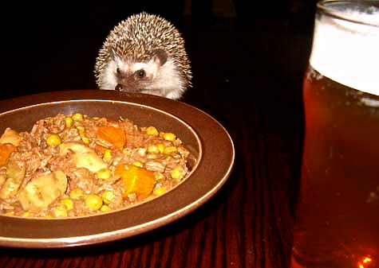
Hedgewig the hedgehog could just do with
a nice spot of tasty stew and a pint!
Notes:
The meat will shred apart nicely by the end of the cooking time. Coating it with the dry ingredients at the start is an Old-World method which serves to thicken the stew nicely as it cooks.

The day before cooking the stew, I put everything in the slow-cooker, except the peas, and store the removable crockery covered overnight in the fridge. That way, all I have to do is seat the crockery back in the slow-cooker the next morning and flip a switch.

