Lovely English Cucumber Sandwiches

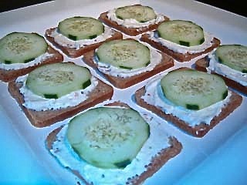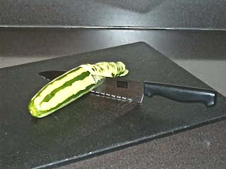

Vegetarians, don't despair - here are some classic British eats for you, too! These tasty little treats became famous from being served at traditional English afternoon tea. They really hit the spot any time on warm summer days, and equally as well on cool autumn evenings.

Ingredients:
8 ounces cream cheese, room temperature
1, 7-ounce packet of dry Italian salad-dressing mix (I use the Good Seasons brand)
¼ cup mayonnaise
1 loaf sliced cocktail-size, whole-wheat or rye bread
1 medium cucumber
A few pinches of dried dill weed

Preparation:
Cut the cucumber very thinly into round slices across the width. Set aside.

Next, combine the cream cheese, salad dressing and mayonnaise. Cover one side of each bread slice well with the mixture. Then lay a cucumber slice over the top and sprinkle a tiny bit of dried dill over each to enhance with an additional layer of flavor and to add extra-nice visual appeal (I also like to sprinkle just the slightest little bit of ground black pepper over each).

Serve chilled on wide platters from which your guests may liberally help themselves. Makes about 30 little open-face sandwiches just perfect for parties.

Notes:
You can prepare the spread days ahead, but assemble your sandwiches no sooner than one hour before eating. Also, you can bet that I use fat-free cream cheese and fat-free mayo (believe me, it tastes great)!

1980s London

They each made me give them a pound-sterling and a cigarette so I could take their picture (the dog posed for free, though).

Don’t worry, I quit smoking in 1989, after I got out of the army and couldn’t afford to buy cigarettes at prices in the civilian economy!

