Coronation Chicken
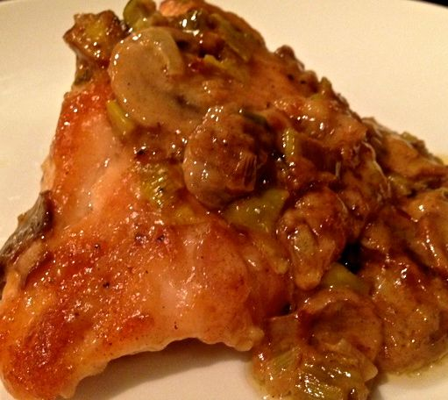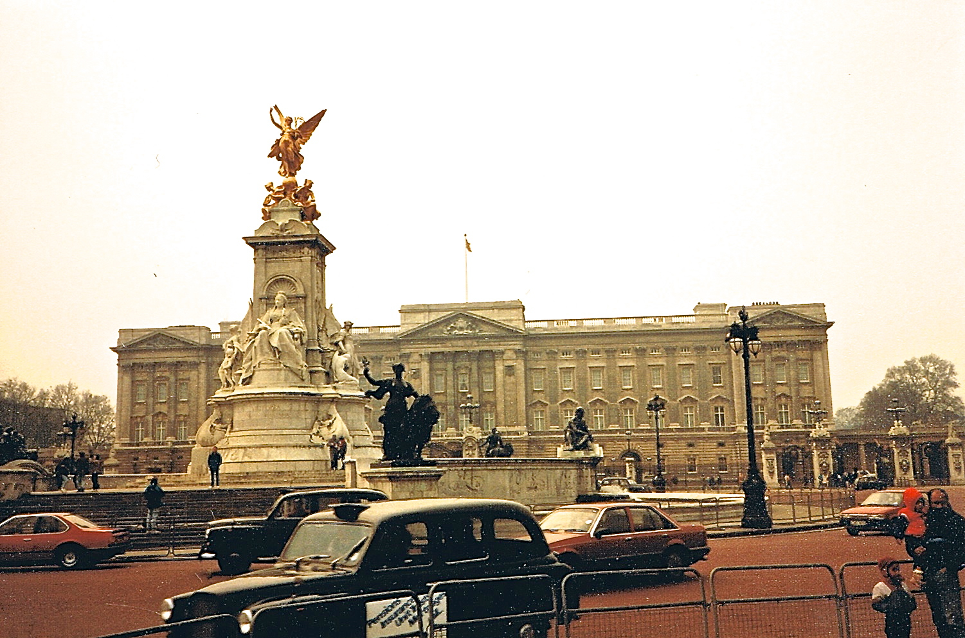

Originally created to celebrate the coronation of Queen Elizabeth II, this recipe didn’t actually get released to the British public until well after the coronation was over. This recipe serves two people, but you can simply increase the amount of chicken and sauce as needed for dinners serving more guests.

Ingredients:
2 boneless, skinless chicken breast halves (chicken “supremes”)
All-purpose flour
2 tablespoons butter
8 ounces small mushrooms, quartered
1 tablespoon minced onion or shallots
½ cup heavy cream
2 tablespoons dry sherry
¾ teaspoon salt
¼ teaspoon of pepper
4½ teaspoons water

Preparation:
Preheat oven to 350° F.

Coat chicken breasts with ¼ cup of flour. You can place them on waxed paper and put the flour on all sides, or put the flour and chicken in a paper bag and give it a good shake.

Put butter in a 12-inch skillet over medium heat, and then fry the chicken until it’s lightly browned on all sides. You’re not cooking it all the way through, just giving it a nice coating and color. If the 2 tablespoons of butter don’t seem to be enough, go ahead and throw in some more.

After you’ve got gorgeous, golden chicken, remove it from the skillet and set it aside in your 9” x 9” baking dish. Leave those drippings in the skillet and, over medium heat, add your mushrooms and onions, stirring frequently during the next five minutes or so.

Your onions and mushrooms will caramelize and begin to smell wonderfully. To this tantalizing mixture, stir in the cream, sherry, salt and pepper, and blend well. In a cup, combine 1 tablespoon flour with 1½ tablespoons of water; gradually add that to the pan, stirring gently, but constantly, until the mixture thickens a bit.

At this point, you are developing the sauce that will go over the chicken. It should be somewhat thick – you don’t want to have a soupy sauce. If it’s more on the soupy side than you’d like, add flour. I always put more sherry in my sauce, and maintain the thick texture by putting in additional flour, continuing to balance the flavors by adjusting the amount of cream, salt, and pepper. Basically, be attentive to the taste and scent of your sauce – that will tell you what you need.

When you’ve got a sauce that you’re happy with, pour it directly over your waiting chicken in the baking dish. Cover and bake for approximately 1 hour, until the sauce is bubbly.

While that’s baking, go relax with a glass of wine, and come back to a lovely dinner!

