Bacon & Onion Pie
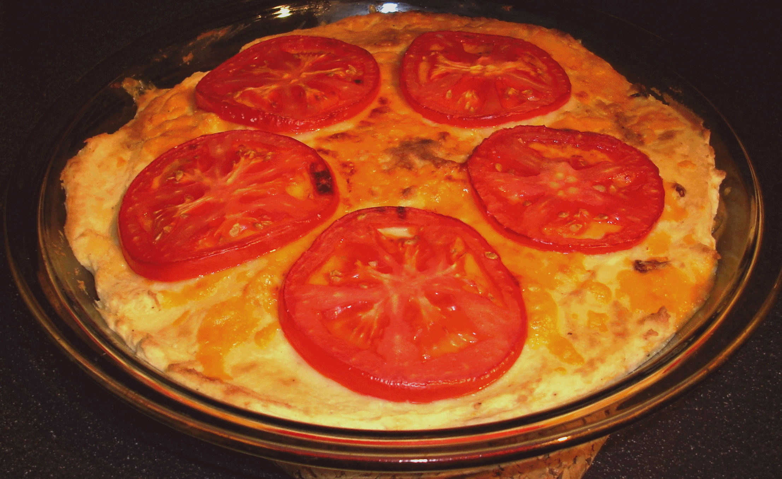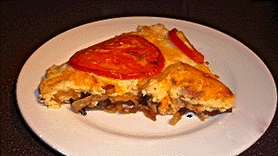

What a marvelously rustic creation this is! The crispy-browned bacon melds perfectly with the savory, caramelized onions. Together with the cheesy, mashed-potato topping covered by the tangy, roasted tomatoes, it makes for a heavenly little brunch component. It also makes a fine main dish served by itself or with baked beans or mushy peas on the side.

Ingredients:
2 cups mashed potatoes (see notes and recipe below)
1 tablespoon vegetable oil
4 - 5 ounces bacon, cut into 1"- 2" pieces (see notes below)
4 ounces butter, divided (see notes below)
2 medium-sized, white onions, halved and finely sliced
¼ teaspoon sugar
5 ounces English or other Cheddar cheese, grated
1 medium, red-ripe tomato, thinly sliced
Salt and ground, black pepper, to taste

Preparation:
Make your mashed potatoes, or warm them through if they've been sitting in the fridge for any amount of time. Set them aside and keep warm.

Heat and cook the bacon in half the butter and all the oil in a medium-to-large frying pan until just beginning to brown and crisp. Remove from the pan with a slotted spoon.

Add the onions to the grease in the pan. Add seasoning to taste, and the sugar. Fry gently over medium heat until the onions are soft and caramelized. Take care not to burn them! Return the bacon to the pan and stir evenly through the onions. Pour the mixture evenly into a standard-sized (9") pie pan.

Add the remaining butter and 4 ounces of the cheese to the potatoes. Season with salt and pepper to taste and mix well. Preheat the oven broiler to the highest setting.

Spoon the potato-cheese mixture evenly over the onions and bacon, sprinkle evenly with the remaining cheese, top decoratively with the slices of tomato and season the tomatoes with just a touch more salt. Place pie under the broiler until the cheese is melted and the top is nicely browned in spots.

Notes:
If I'm too terribly lazy to make homemade mashed potatoes for this, I buy a enough of a store-bought brand for two cups' worth. It works great!

If watching your fat and/or cholesterol intake, it works fairly well to use some commercial butter substitute, like "I Can't Believe It's Not Butter," or just use an additional measure of olive oil instead of butter.

The bacon used for this is what the Brits refer to as "streaky bacon," and that's the kind of bacon that we Americans all know and love to eat with our eggs and toast in the morning. Brits normally eat what they call bacon "rashers" with their eggs in the morning. A bacon rasher is a thin, floppy slice of fatty ham. The closest thing I can compare a bacon rasher to is an unsalted, much less lean slice of Canadian bacon (but a British bacon rasher is not round like Canadian bacon - it's a longer, narrower slice of thin ham-meat, as you can see in the picture below). I personally do not really care for bacon rashers, unless they are well browned!

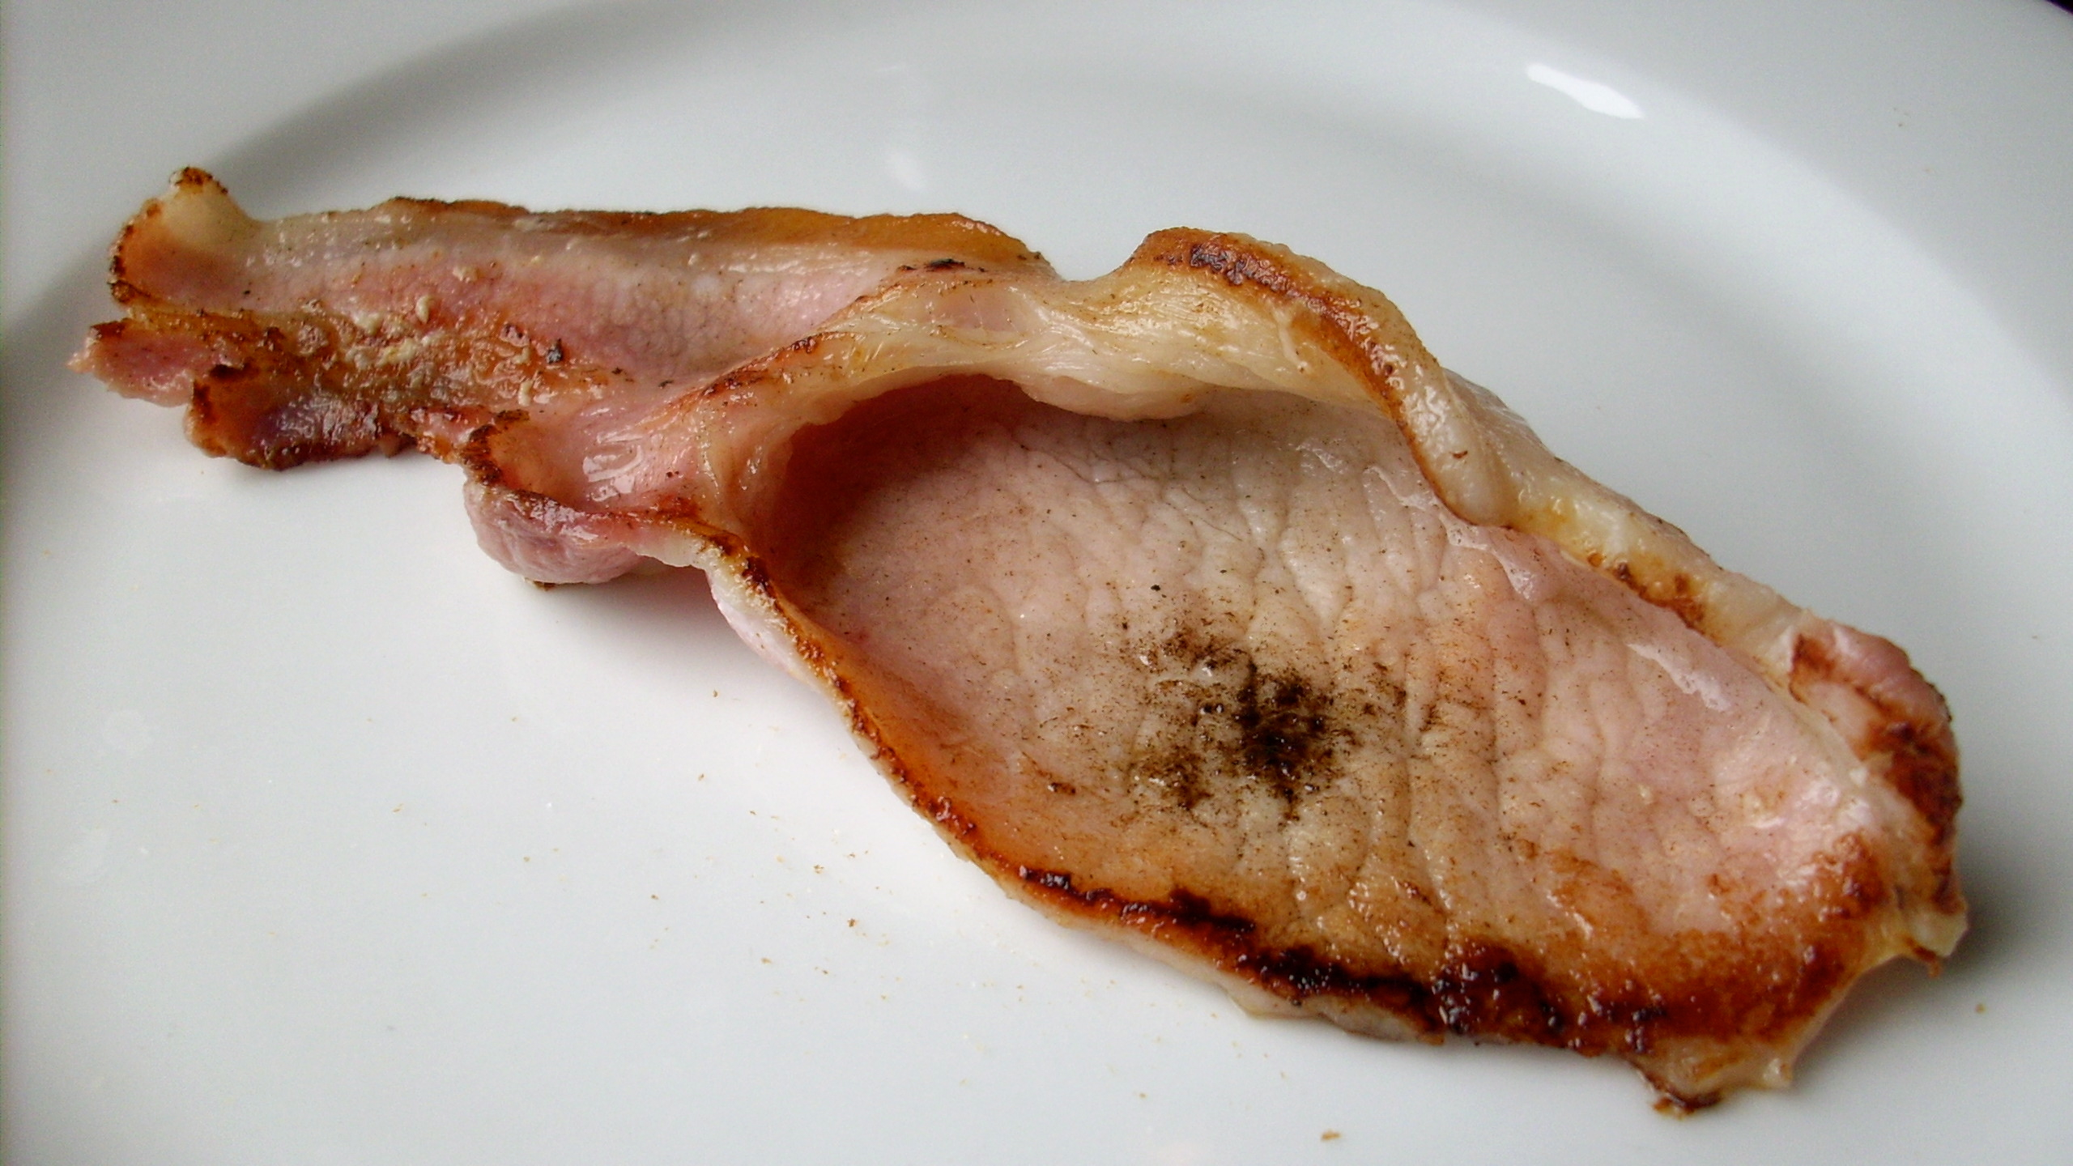
An English bacon "rasher" - not the kind of bacon used in this wonderful dish.

Mashed Potatoes for Two (“smashed” potatoes, as the Brits like to call them) are quite popular as a side dish in Great Britain.

Ingredients:
12 - 16 ounces waxy potatoes (1 serving is 6 – 8 ounces), I like to use Yukon Golds
¼ cup milk, cream, half-and-half or other liquid dairy to thin the potatoes
3 tablespoons of butter
Salt and ground, black pepper

Preparation:
Peel and quarter the potatoes. Start a large pot of water boiling - add just enough water to cover all the potatoes. Add some salt to the boiling water and cook until the potatoes are tender (about 15 minutes). Drain the potatoes and mash by hand with potato masher. Blend in butter and milk until creamy. Season with salt and pepper.

