Sichuan Smashed Cucumbers (recipe makes about 4 servings)

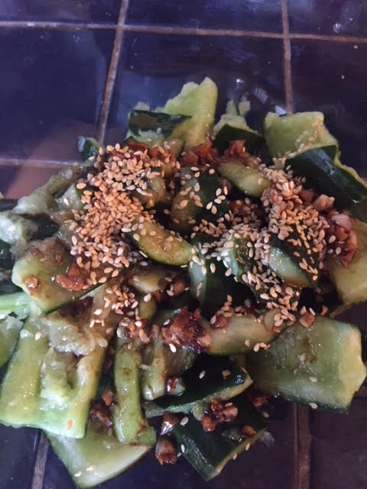

Traditionally, this is meant to be eaten with spicy food. But if you eat it alone as a side dish, dress it with a little Asian chili paste.

Ingredients:
2 English cucumbers, cut into thirds – do not peel them
¾ teaspoon table salt
4 teaspoons of Chinese black vinegar (or you can use balsamic vinegar)
1 teaspoon of minced garlic
1 teaspoon of sesame seeds
1 tablespoon of soy sauce
2 teaspoons of toasted sesame oil
1 teaspoon of sugar

Preparation:
Cut The ends off of two English cucumbers, then cut them in thirds. Do not peel them, but wash them very well. Put them in a gallon Ziploc and beat them with a rolling pin or a 9” all-clad pan until they flatten out. Put the smashed pieces in a colander over a wide bowl - tear them into 1” to 1 1/2” pieces. Sprinkle them with ¾ teaspoon table salt. Toss them with the salt and let them sit for 15 to 30 minutes.
Mix 4 teaspoons of Chinese black vinegar with 1 teaspoon of minced garlic. Let that sit for 5 - 15 minutes. Next, toast 1 teaspoon of sesame seeds on a skillet over medium heat for 3 to 5 minutes.
Make a dressing by adding 1 tablespoon of soy sauce to the garlic/vinegar mixture. Also add 2 teaspoons of toasted sesame oil and 1 teaspoon of sugar to the mixture.
Put the smashed cucumber pieces in a bowl. Do not rinse them. Pour the dressing over them and also the toasted sesame seeds. Toss everything well.

