The Pioneer Woman’s Short-Cut Beef Phò Recipe Made from Simple Ramen Noodles

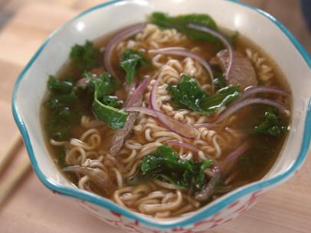

Ingredients:
4 ounces sirloin steak, very thinly sliced into 6 – 8 paper-thin slices
1 package beef-flavored ramen with seasoning packet
½ red onion, thinly sliced
2 tablespoons sriracha
1 tablespoon soy sauce
1 teaspoon fish sauce
½ cup torn kale
1 teaspoon minced fresh ginger
2 cups boiling water
1 lime

Preparation:
Zest the lime. Juice ½ of the lime and cut the other half into 2 wedges. Layer the ramen and seasoning, onion, sriracha, soy sauce, fish sauce, kale, lime zest and juice, ginger and steak in a large heatproof soup bowl. Pour the boiling water into the bowl and let it sit undisturbed for 2 minutes. Stir with chopsticks, garnish with the lime wedges and serve immediately.

