Kung Pao Beef for Two

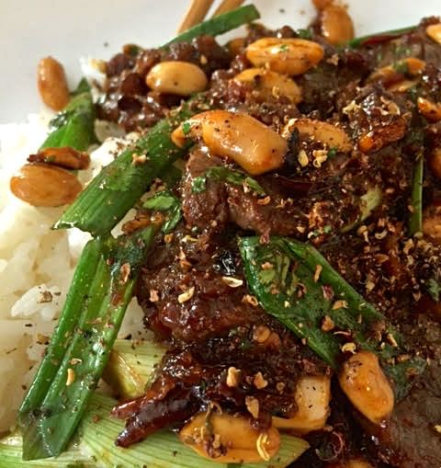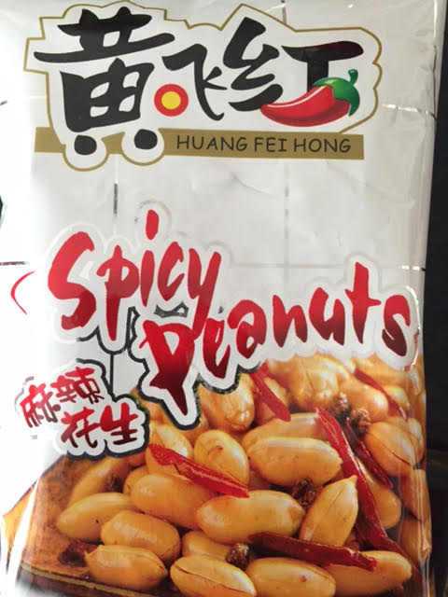

Ingredients:
½ pound beef tenderloin, skirt steak, flank steak or hanger steak
Salt and ground, black pepper
1 tablespoon cornstarch
1 tablespoon ketchup (it was invented in China, after all!)
1 tablespoon Shaoxing rice wine or dry sherry
1 tablespoon soy sauce
1 tablespoon Chinkiang black rice vinegar or balsamic vinegar
1 heaping teaspoon Chinese chili sauce
2 teaspoons Sichuan peppercorns
2 tablespoons peanut oil
2 – 4 dried red chilies, crushed
2 fresh chilies, smashed and cut into ¼“ slices
¼ cup dry roasted peanuts
2 tablespoons chopped fresh cilantro stems and leaves
1 scallion, cut into 2” pieces, both green and white parts

Preparation:
Slice the beef across the grain into chopstick-friendly pieces. Sprinkle it with salt, pepper and coat it well with the cornstarch. Set aside. In a small bowl, stir together the ketchup, rice wine, soy sauce, vinegar and chili sauce. Set aside.
In a wok or other pan over medium heat, toast the Sichuan peppercorns until fragrant, 1 to 2 minutes. Remove from the heat and pulverize ¾ teaspoon of the peppercorns in a spice grinder, or in a plastic bag with a rolling pin. Set aside. Leave the remaining peppercorns whole.
Heat the wok up to high heat and, when it starts to smoke, add the peanut oil. Add the whole Sichuan peppercorns, dried chilies and fresh chilies, then stir-fry for a few seconds. Add the beef and stir-fry until the beef is brown. Add the reserved sauce and peanuts; cook until the sauce has reduced slightly and is sticky with a thicker consistency (it should only take a few seconds). Add the cilantro and scallions and toss to coat and warm through. Then transfer to a serving plate and garnish with the ground Sichuan peppercorns. Serve immediately with steamed rice.

