Japanese Yakisoba for Two

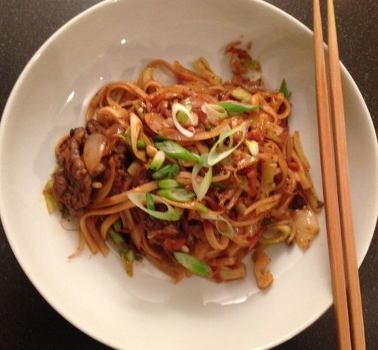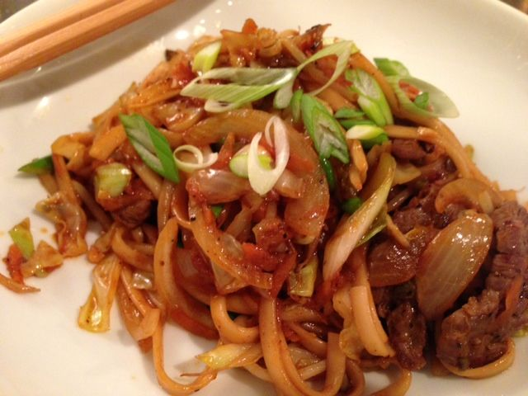

Yakisoba means “fried noodles” and is commonly found all over Japan at festivals, sporting events, and shops that specialize in okonomiyaki (a type of Japanese pancake). Despite having “soba” in the name, yakisoba is actually made with thin Chinese egg noodles, not buckwheat soba. By adding your choice of meat, seafood and vegetables, you can customize it to your tastes as well as what you have available. The sweet, tangy tonkatsu sauce gives the noodles a deep mahogany color and a unique, caramelized flavor.

Ingredients:
2 tablespoons oil
¼ pound thinly-sliced meat or seafood such as shrimp, squid or octopus
4 ounces roughly-chopped cabbage
4 ounces bean sprouts
2 ounces yellow onion, sliced
2 ounces carrot, shredded
4 ounces cooked, thin Asian egg noodles
2 scallions, sliced thin on the bias
1 clove garlic, minced
tonkatsu sauce – mix 1 tablespoons ketchup (see note below), 2 tablespoons soy sauce, 2 tablespoons mirin rice wine, and 1½ teaspoons Worcestershire sauce
1½ teaspoons gochujang (borrowed from Korea – it’s fermented hot-pepper paste), or you may simply use red-chili flakes
aonori (green nori flakes), optional
benishoga (red pickled ginger), optional

Preparation:
Boil your noodles ahead of time and dress with a little sesame or olive oil to prevent them from sticking together. If you are using meat or seafood, season with salt and pepper, then heat a tablespoon of oil in a pan or wok until smoking hot and fry the meat in it until nicely browned. Transfer to a plate and set aside.

Sauté the cabbage, bean sprouts, onions, and carrot until they are mostly tender. Add the noodles, scallions and garlic, then cover with the remaining oil (1½ teaspoons). Stir-fry the noodles until they are completely separated and there is no water remaining. Add the meat/seafood back into the pan along with the tonkatsu sauce and gochujang; stir-fry until the sauce evenly coats the noodles. To serve, plate the noodles and top with a sprinkle of aonori flakes and benishoga, or sliced scallion.

Notes: Ketchup has its origins in late 17th-Century China. Gochujang (hot pepper paste) was first used in Korea in the late 18th century, after chili was introduced by Japan in the 16th century.

