Japanese Tempura

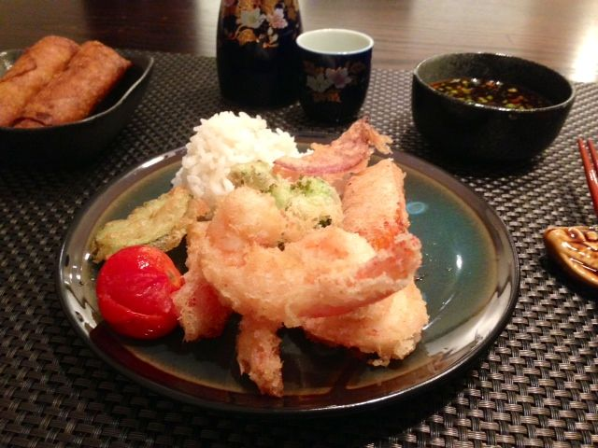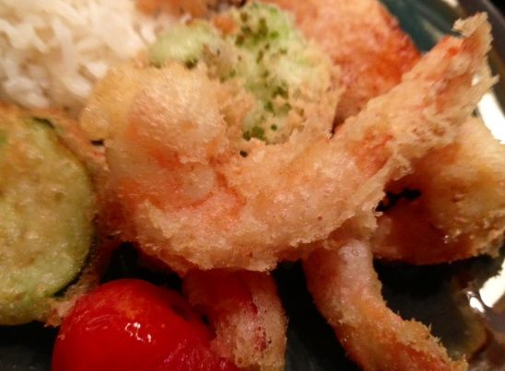

Ingredients for 2 Servings:
8 – 10 peeled (tail-on), deveined shrimp (medium-sized)
About 7 – 8 ounces sliced vegetables, like zucchini, broccoli florets, carrots, mushrooms, bell peppers and other vegetables to taste – see notes below.
3 cups of vegetable oil for frying
Salt

For the Batter (enough for 2 servings)
¾ cup all-purpose flour
¼ cup cornstarch
½ cup seltzer water/soda
½ cup 80-proof vodka (you read it right – it helps keep the batter light and delicate!)
1 small egg, or half a large one (beat it well first to divide equally in half)

For the Dipping Sauce (for 2 servings)
¼ cup soy sauce
3 tablespoons Mirin (sweetened Japanese rice wine – make sure to use an expensive, imported brand that’s aged at least one year)
1 teaspoon sugar
1 teaspoon Asian-style sesame oil
I clove garlic, minced
2 teaspoons grated ginger
1 scallion, finely minced

Preparation:
Preheat your oven to 200° F. Line a baking sheet with foil and set a wire rack in it – this is to keep your tempura warm while frying in batches.

Keep the prepared shrimp refrigerated until ready to cook.

Combine the flour and cornstarch together well in a large mixing bowl. In another mixing bowl, beat the egg. Add in the vodka, mix well. Add in the seltzer, mix it together and let it sit, separate from the flour mixture, while your vegetable oil heats up to 350° F.

Meanwhile, combine the dipping-sauce ingredients; set aside.

When the oil is hot, gently whisk the flour/cornstarch and seltzer/vodka mixtures together well in one bowl (don’t over-mix; a few specks of flour are OK!). Dip your frying components into the batter, shake off excess batter and drop them into the oil, one-by-one. Fry for 3 - 4 minutes. Make sure they don’t stick together!

Transfer each batch to a paper-towel lined plate to absorb the excess oil, sprinkle generously with salt and transfer to the heated wire rack in the oven to keep warm while you finish up. Let the oil reheat back up to 350° F. before dropping in the next batch to fry!

Serve with jasmine rice, spring rolls and good, Japanese sake or plumb wine.

Notes:
Common Ingredients for Tempura: Shrimp, squid, scallops, eel, crab, green bell pepper, eggplant, sweet potatoes, potatoes, carrot, shiitake mushrooms, lotus roots.

The tempura batter is great for frying onion rings!

