Japanese Fried Chicken (Karaage) for Two

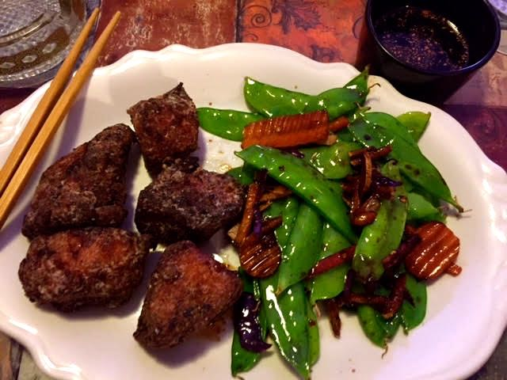

Ingredients:
½ pound boneless, skinless chicken pieces
1 2” knob fresh ginger, large grated – reserve a small portion for the dipping sauce
Zest of 1 small lemon
4 tablespoons mirin
4 tablespoons soy sauce
½ teaspoon black pepper
1½ teaspoons Japanese spice blend (Shichimi Togarashi – Milwaukee’s Spice House)
½ cup cornstarch
To make a dipping sauce, you’ll need 3 tablespoons soy sauce, 3 tablespoons rice wine vinegar, ½ teaspoon toasted sesame oil and 1 teaspoon finely grated ginger

Preparation:
For the marinade, gather up the grated ginger and squeeze the juice in a bowl, then throw the ginger gratings in. To that, add the lemon zest, the mirin and soy sauce; stir well, then marinate the chicken in the mix for 30 minutes to 1 hour.
Mix the black pepper and the Japanese spice blend with the cornstarch. Scrape the larger pieces of ginger gratings off the chicken pieces and dredge them in the cornstarch mixture (I shake them all up in a paper bag). Refrigerate the coated chicken pieces. Don’t let it sit for more than one hour or it will get gummy.
While the chicken rests in the refrigerator, make a dipping sauce by combining 3 tablespoons soy sauce, 3 tablespoons rice wine vinegar, ½ teaspoon toasted sesame oil and 1 teaspoon finely grated ginger.
Deep-fry the chicken pieces in 375° oil. Fry the chicken for about five minutes, until it is nice and golden brown. Serve with steamed rice and vegetable stir-fry.

