INDIAN CHILLI CHICKEN

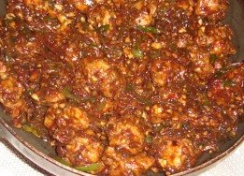 Recipe serves 2.

INGREDIENTS:

200 – 300 gms. (about ½ lb.) boneless chicken, cut into1” cubes
1 TBS. soy sauce
1 egg
1 TBS. corn flour / corn starch, divided
3 - 6 green chilies, finely chopped
tops of 1 green onion for garnish, finely chopped (if available)
½ tsp. garlic paste
salt, to taste
¼ tsp. white-pepper powder, or to taste
½ tsp. sugar
a pinch of ajinomoto (optional)
1 cup chicken broth / water
½ TBS. oil
oil to fry

PREPARATION:

Mix ½ TBS. of the soy sauce, ½ TBS. corn flour, the salt and the egg in a bowl; marinate the chicken pieces in the mixture for 15 minutes.

Heat oil and deep-fry the marinated chicken pieces ‘till golden brown.

Now, in a separate wok / kadhai, heat up the ½ TBS. oil, then add the garlic paste and green chilies; sauté for a few seconds, until the odor blossoms.

Add the chicken broth or water. Bring to a boil and add the sugar, pepper powder, salt, ajinomoto (if using) and remaining soy sauce.

Add the fried chicken pieces to it and cook for few minutes.

Dissolve the remaining corn flour in ½ cup water and add to the curry, stirring constantly to avoid lumps. Cook for 2 - 3 minutes.

Serve chilli chicken hot garnished with chopped green onion tops. Goes well with steamed / boiled rice.

