Tuna and Rice Bake (recipe makes 4 servings)

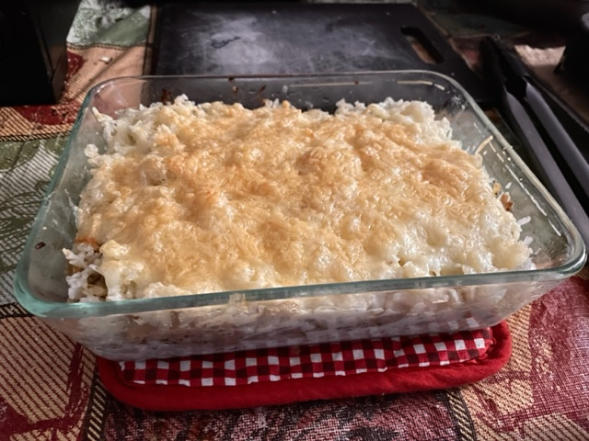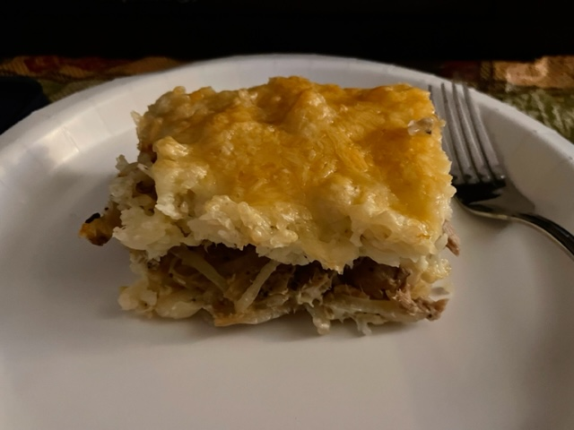

Forget tuna & noodles! The sautéed onion makes this light dish succulent.

Ingredients:
1 cup rice (2 cups cooked)
1 small onion, thinly sliced
1 7-ounce can tuna
Salt and black pepper, to taste
Butter, for greasing the pan
2 eggs, beaten
½ cup milk or cream
½ teaspoon granulated garlic powder
1 cup grated cheese – Gruyère goes really well with this

Preparation:
Preheat oven to 350° F. Boil rice. Set aside and let cool.

Sauté onion until brown. Stir in tuna, salt and pepper. Cook a few minutes.

Grease 6" (small) baking dish or ovenproof skillet with butter. Layer in half of the cooked rice (try not to pack it down too firmly). Top with the tuna-onion mixture, then cover loosely with the rest of the rice - smooth it all out evenly.

Whisk together the milk or cream, eggs, salt, pepper and garlic powder. Cover the rice in the baking dish with the egg mixture. Top evenly with grated cheese. Bake at 350° for 15 minutes.

