Glazed Strawberry Bread – recipe makes about 10 servings

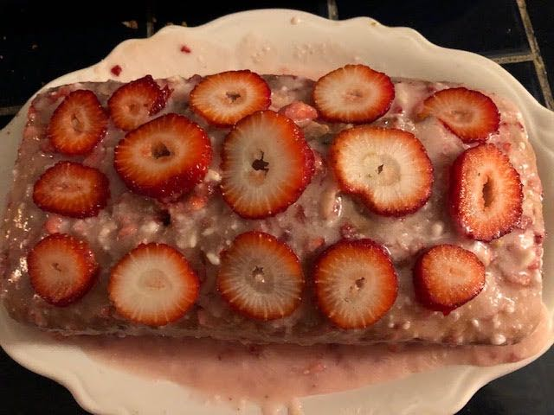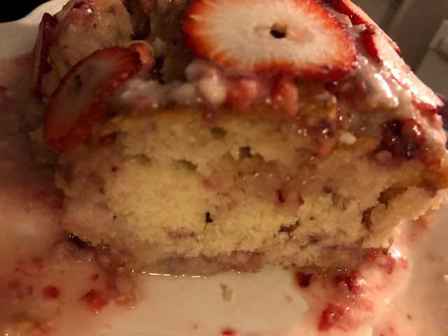

This “bread” actually turns out to be a sweet cake dessert! You can change up the fruit and make blueberry “bread,” raspberry “bread,” even pineapple “bread”!
Ingredients:
For the Bread:
¾ cup granulated sugar
½ cup milk
½ cup oil
1 large egg
1 teaspoon vanilla extract
2 cups all-purpose flour, plus an additional, separate 2 tablespoons all-purpose flour
2 teaspoons baking powder
¼ teaspoon salt
2 cups diced strawberries (I just pulse whole strawberries in the food processor)
2 – 3 whole strawberries, sliced (to garnish the loaf)
For the Glaze:
2 cups powdered sugar
2 tablespoons melted butter
⅓ cup finely diced strawberries
½ teaspoon vanilla extract or almond extract
1 – 2 tablespoons heavy cream or milk
Preparation:
Preheat the oven to 350° F.

In a medium bowl, stir together the sugar, milk, oil, egg and vanilla. In a separate bowl, combine the flour, baking powder and salt. Add the dry ingredients to the wet ingredients and stir until just combined.

In a small bowl, toss together the strawberries and the 2 tablespoons of flour to
coat the strawberries. Fold the floured strawberries gently into the batter.

Pour the bread batter into a greased 9" x 5" bread pan. Bake at 350° F for
50 – 55 minutes. A toothpick inserted in the center of the bread should come out clean. Allow the bread to cool for 10 minutes, then remove the bread to a wire rack to cool completely.

To make the glaze, combine the powdered sugar, melted butter, diced strawberries, extract and milk/cream in a small bowl. Mix until it is smooth.

Once the bread is cool, spread the glaze on top of the bread and garnish with strawberry slices. Slice and serve.

