Elegant and Easy Pork Chops with Wine & Garlic for Two

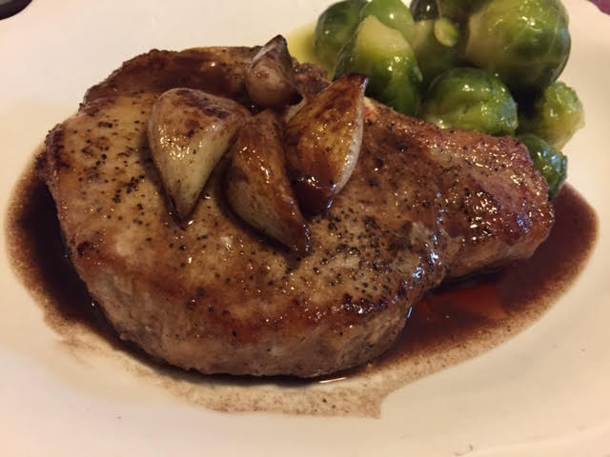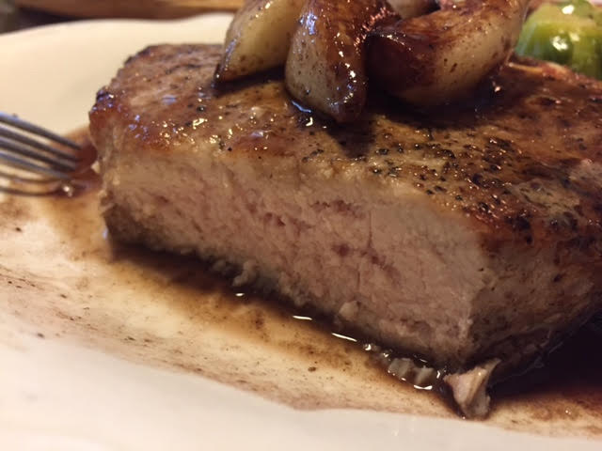

Ingredients:
2 whole, bone-in pork chops (medium-to-thin)
1 tablespoon olive oil
2 tablespoons butter, divided
Salt and ground, black pepper, to taste
⅔ cup red wine
½ cup beef broth (more if needed)
1 whole bay leaf
1½ teaspoons balsamic vinegar
8 – 12 whole, peeled garlic cloves

Preparation:
Heat oil and 1 tablespoon butter in a heavy skillet over high heat. Season both sides of the pork chops with salt and pepper; sear them on both sides until they’re just golden brown, but not cooked through. Remove them from the skillet and set aside.

Reduce the heat to medium-high, add in the garlic cloves. Sauté until they’re golden brown. Pour in the wine, then add in the bay leaf. Stir and let it reduce, raising the heat if necessary. Cook the sauce for several minutes, until it’s reduced and thick.

Stir in the beef broth and add back the chops with any accumulated juices into the cooking liquid, arranging them so that they’re swimming in the sauce. Allow the chops to cook in the liquid for a few minutes, then pour in the balsamic. Shake the pan to get it to distribute, then cook for a couple more minutes, or until the pork chops are done.

Remove the chops from the pan and arrange them on two plates. Let the sauce reduce a little more, if needed, until it’s very thick and rich and the garlic is soft.

Swirl in the other tablespoon of butter and sprinkle in a little salt and pepper, then pour the whole skillet of sauce (including garlic) over the tops of the chops on the two plates.

