Depression-Era “Poor Man’s Meal”

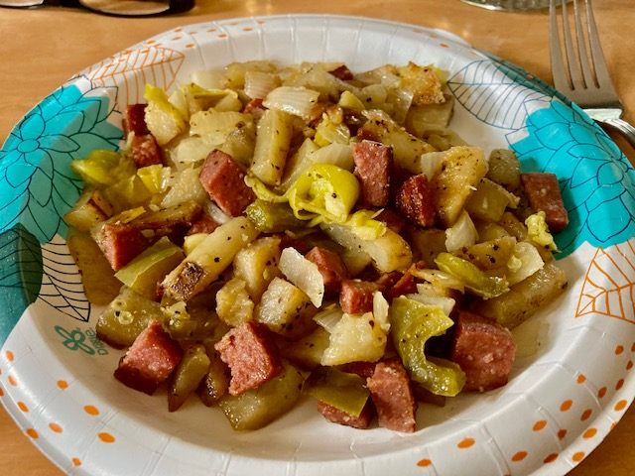

Ingredients:
4 potatoes, diced
2 onions, diced
3 hotdogs or diced ham
2 Tablespoons olive oil
2 Tablespoon tomato sauce (optional)
½ cup water or broth
Salt, Pepper and Cajun seasoning, to taste

Preparation:
- In a 12” sauté pan, add 1 Tablespoon of the olive oil.
- Add the potatoes and onion, season with salt and pepper, and cook over med-high heat until browned, adding additional oil as needed.
- Add the meat and tomato sauce, if using.
- Add the water/broth to help soften the potatoes.
- Cook over medium heat until potatoes are tender.
- Serve.

NOTE:
I also like to throw in some chopped green-bell and hot, yellow peppers with the onions and potaoes, if I have any on hand. I’ve also made this with diced Canadian bacon. I bet regular, crispy-fried bacon would be REALLY good!

