Pickle Ham Sandwiches for Two

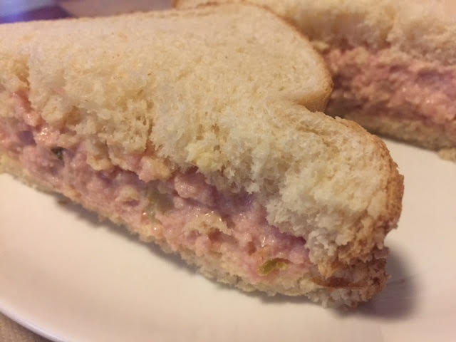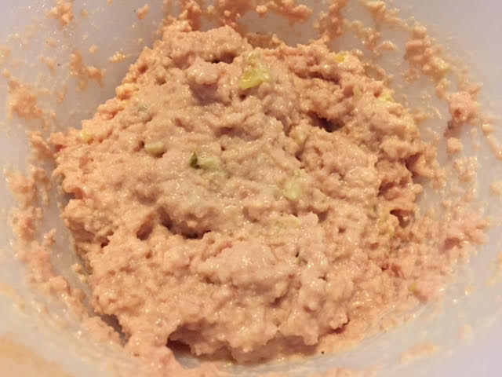

This recipe has been a family favorite of my friend, Clay, going back to when his family lived in North Dakota (he and his family relocated to Seattle quite a few years ago). He calls it “ham and pickle” sandwiches, and his version simply calls for putting cubed ham and pickle spears to taste through a meat grinder. But I thought there has to be more to it than that, so I did a little research on line and found that his family’s recipe is a stripped down version of devilled ham. The following recipe is what I ran into on line more often than not (this recipe makes 2 sandwiches).

Ingredients:
4 ounces (.25 lbs) ham, very finely minced (I do it in a food processor)
4 tablespoons mayonnaise
2 teaspoons minced dill pickle (chopping up 5 – 6 big dill pickle slices does the trick)
1 teaspoon Dijon mustard
A dash (or two) of hot pepper sauce (like Tabasco), or to taste
4 bread slices
Butter

Preparation:
Mix all ingredients, except of course the bread and butter, thoroughly.

Spread on lightly buttered bread to make two sandwiches. People also butter the outside of the bread and lightly fry the sandwiches in a skillet, like grilled cheese and Reubens.

I like serving these with raw vegetable crudités and additional pickle spears.

