Easy Peach Cobbler (recipe makes 4 – 6 servings)

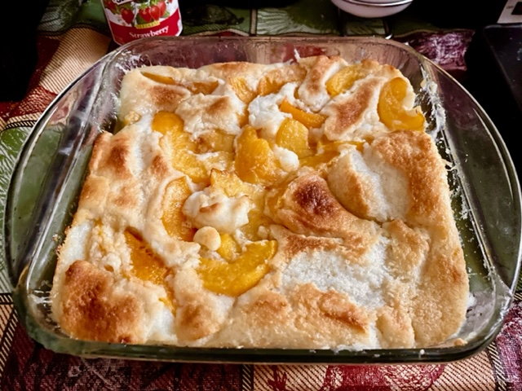

Ingredients:
½ cup (1 stick) unsalted butter, melted
1 cup all-purpose flour
1½ teaspoons baking powder
½ teaspoon salt
1 cup white sugar
1 cup milk
2 (16 ounce) cans sliced peaches

Preparation:
Preheat the oven to 350 F°.

Mix the flour, baking powder, salt, sugar, and milk together in a bowl until well combined and no lumps remain.

Pour melted butter into a 9- or 10-inch baking pan. Pour flour-milk mixture over top.

Carefully pour peaches into the pan, spreading peaches evenly around the pan.

Bake in the preheated oven until the crust turns golden brown, 30 to 45 minutes.

Remove from the oven and let cool for about 10 minutes before serving.

