Paprika Parmesan Baked Chicken for Two

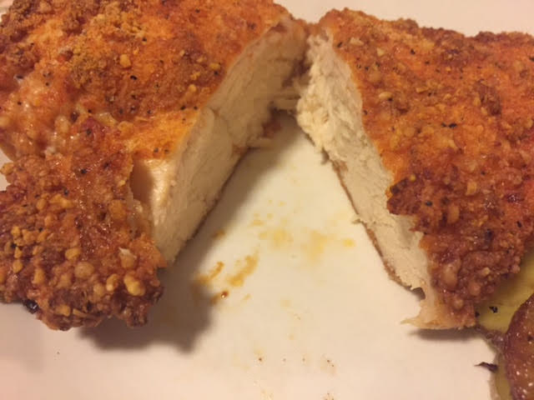

Ingredients:
2 boneless, skinless chicken breasts
1 egg
¼ cup all-purpose flour
½ cup Parmesan cheese
½ teaspoon salt
½ teaspoon ground black pepper
1 teaspoon garlic powder
2 teaspoons paprika
¼ cup melted butter

Preparation:
Preheat oven to 400° F. Beat the egg in a bowl.

In another bowl, thoroughly mix together the flour, Parmesan, salt, pepper, garlic powder and paprika.

Dip the chicken breasts in the egg, then dredge them in the flour mixture (I shake the chicken with the flour mixture in a paper bag); place on a foil–lined baking sheet and drizzle with the melted butter. Bake in the preheated oven 40–45 minutes.

