Oregon Blackberry Pie

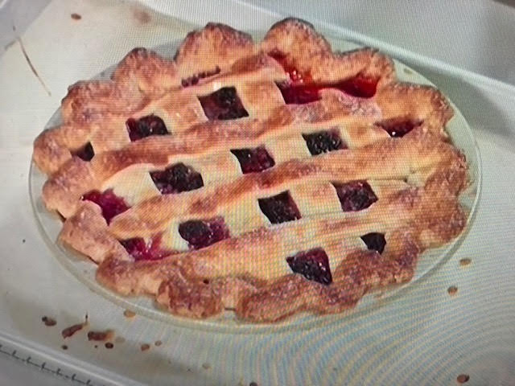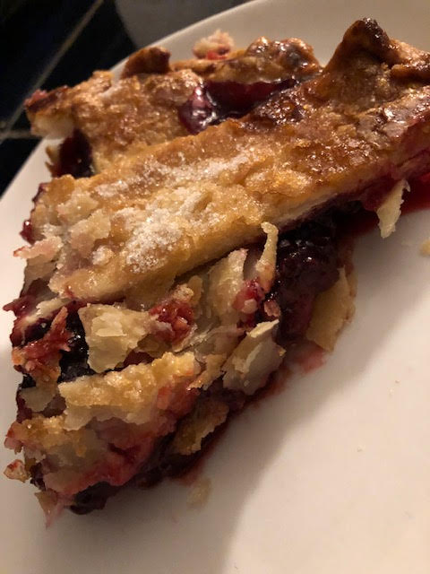

The state of Oregon harvests the most blackberries in the United States of America! This pie is all about butter, sugar and blackberries. Mmm! MMMMM!

Ingredients:
2, 9” piecrusts
1 cup sugar
¼ teaspoon salt
5 tablespoons cornstarch
20 – 24 ounces (more or less – about 2½ cups) blackberries
2 tablespoons lemon juice
2 tablespoons room-temp, unsalted butter
1 egg, beaten with 1 tablespoon water to make an egg wash

Preparation:
Preheat oven to 400° F.

If using frozen blackberries, thaw them on a plate at room temperature for about an hour. Mix ¾ cup of the sugar, the salt, cornstarch, blackberries and lemon juice together well until no white powder showing. Put bottom piecrust in pie dish, then pour in the filling. Dot with the butter.

Cut the top crust into eight strips to form a lattice top. Place four straps over the pie filling in the pie pan and brush with egg wash. Press firmly to the bottom crust. Place the remaining four strips of piecrust over and across the four that are on the pie. Press those firmly in place. Trim the lattice strips down to half an inch on the pie plate with a butter knife or kitchen shears. Turn the edges inwards and crimp the edge as nicely as you can. Brush the whole thing with more egg wash, then sprinkle the remaining sugar over the entire top. Bake for 45 - 50 minutes. Rotate the pie halfway through the baking. Unfortunately, you have to cool the pie at least 4 hours before slicing/serving (sorry, but the filling has to have time to gel).

