Virtually No-Carb Piecrust – recipe makes a single 9” piecrust

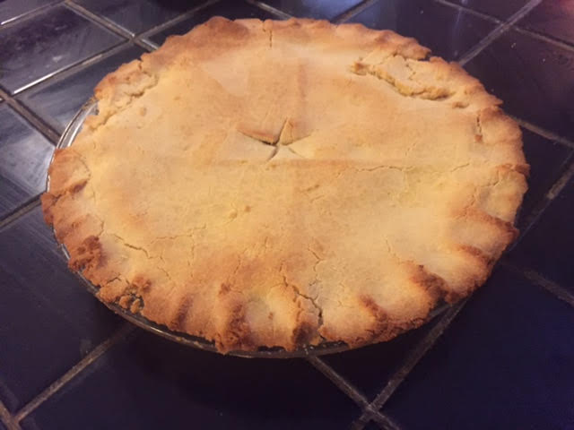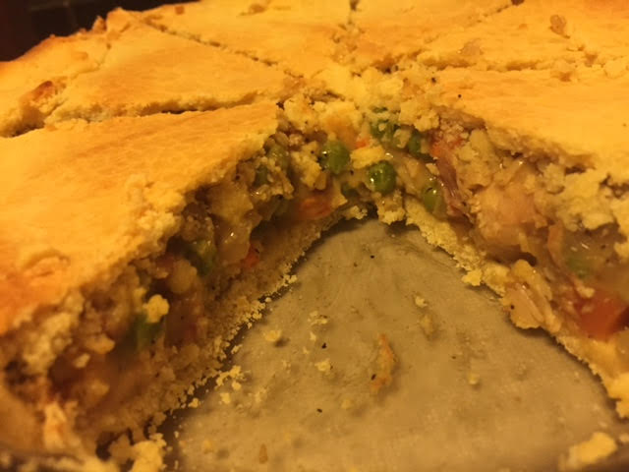

This is probably the most aggravating recipe I’ve ever undertaken. The pie dough is really hard to work with. As you can see by the picture, I had to do a lot of patching up because it’s not as flexible and forgiving as regular carb-loaded piecrust dough. But the end result is well worth it if you’re gung-ho paleo! Note that you’ll have to double this recipe if you need two piecrusts.

Ingredients:
2 eggs
1 tablespoon olive oil
1 teaspoon vanilla extract (leave out for savory pies)
¼ cup artificial sweetener (leave out for savory)
¼ teapoon salt
1 cup coconut flour (I use Bob's Red Mill)
½ cup butter (one stick), cold and cut into cubes

Preparation:
Preheat oven to 400° F. Whisk the eggs, oil and vanilla extract in a bowl with an electric mixer. Slowly mix in the remaining ingredients together until combined.

Stir the butter cubes into the mixture, then spoon it into a food processor. Process until it has a crumbly consistency. Squeeze the crumbles together with your hands until you form a ball of dough (I wear washed latex gloves). Roll out between two pieces of parchment paper and flip over into a 9” pie plate. You can also just spread the dough into the pie plate and press using your fingers.

Using a fork randomly make form hole into the bottom of the crust. Bake the crust 10 minutes or until golden. Once cooled out of the oven, add your filling.

If using this for a savory or sweet pie with a top and bottom crust that needs to be baked for longer than 10 minutes (like in my pictures above), cover the crust edges with aluminum foil to prevent burning.

