Macaroni & Cheese (recipe makes 4 servings)

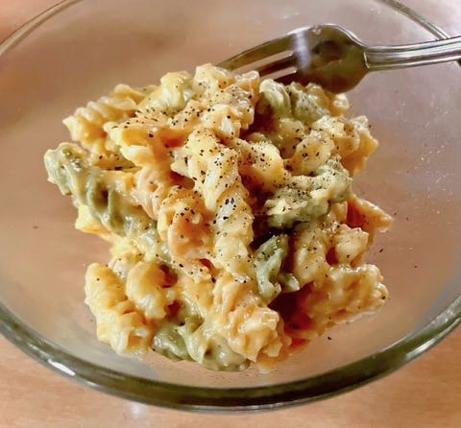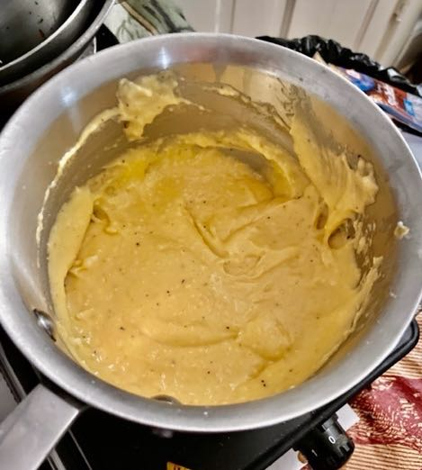

Easiest recipe for home-made, classic mac n’ cheese!

Ingredients:
6 - 8 ounces macaroni or other pasta, cooked to package directions
2 tablespoons of butter
2 tablespoons of flour
1 and 1/4 cup of milk
1 cup (a 7-ounce sleeve) of shredded cheese such as Colby Jack
¼ cup grated Parmesan

Preparation:
While your pasta, cooks, melt the butter over medium heat in a 2-quart saucepan.

Add flour, whisk until smooth, making a roux.

Heat the roux until it bubbles, and then cook for 1 more minute, whisking constantly.

Slowly add the milk, whisking constantly.

Heat until the mixture bubbles and thickens, frequently stirring (if the mixture is too thick, add more milk 1 tablespoon at a time).

Add the cheese and stir until smooth.

Season with salt and pepper. Add additional seasonings to taste (garlic powder, chilli powder, red pepper flakes, etc.).

