**Patrick Holbrook’s Crowd-Pleasing Lil’ Smokies in a Slow Cooker**

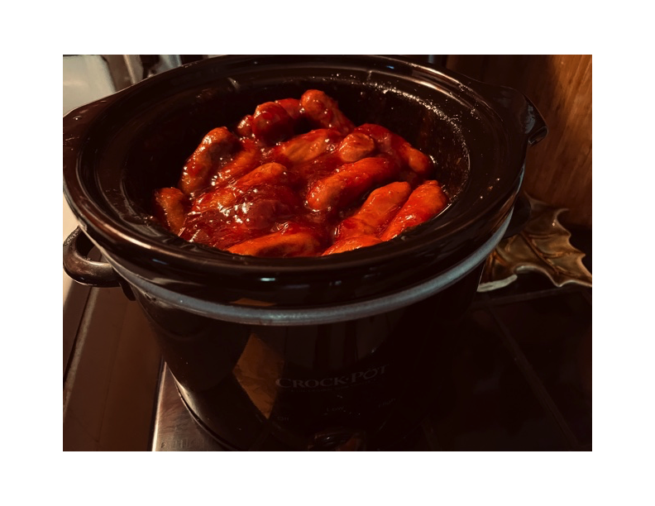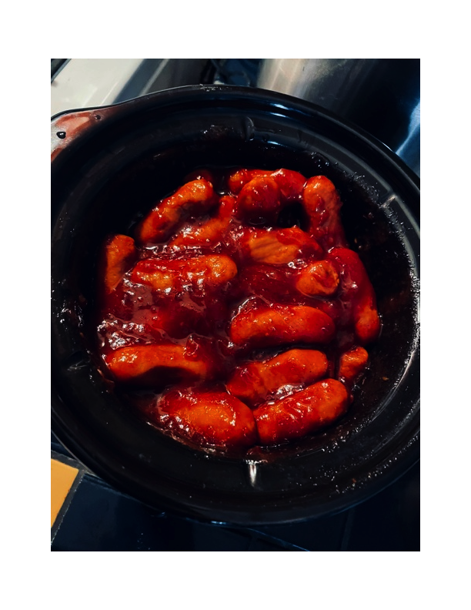

Boy, my friend, Patrick, wasn’t kidding when he said this was just about the easiest recipe in the world to make! Being cheap, easy and quick to throw together, it’s great to take to parties and family get-togethers. I make a pot of them once in a while at home just to snack on all day!

Ingredients:

2 14-ounce packages Hillshire Farms Lit’l Smokies cocktail sausages

1 14-ounce can jellied cranberry sauce

1 12-ounce bottle chili sauce

Preparation:

In a large bowl, thoroughly whisk together the sauces. Fold in the sausages. Place the mixture in a small crock-pot/slow cooker and heat on high 4 to 6 hours. You can then turn them to the low setting and let them sit to keep hot all day and all night!