Lighthouse Inn Potatoes (recipe makes 8 – 10 servings)

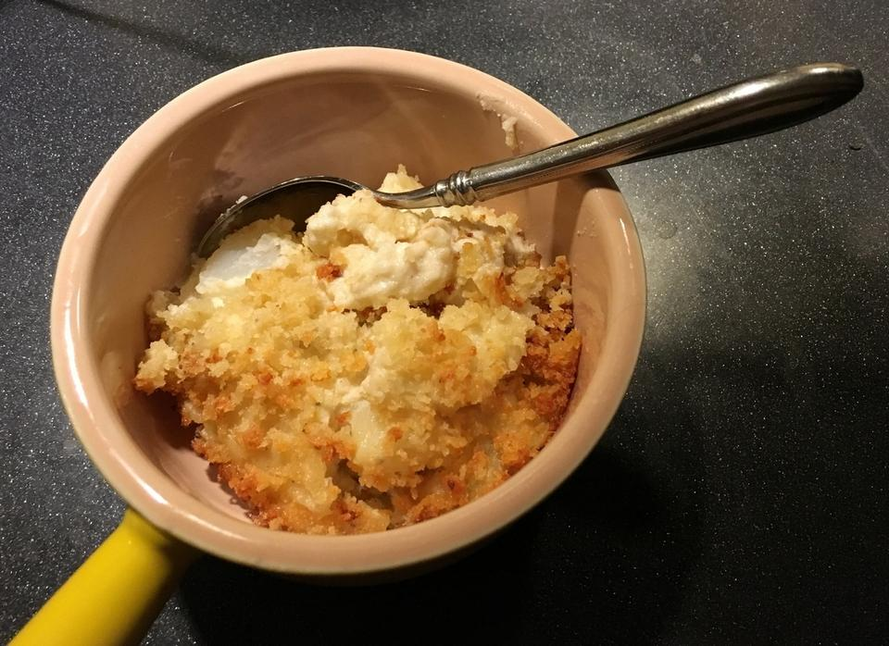

Many who grew up, lived in or just visited New London, CT during the heyday of the Lighthouse Inn have the fondest memories of the old place, its genial, festive atmosphere and its delicious food. Lighthouse Inn Delmonico Potatoes, in fact, have lived on long after the inn itself, which has been closed since 2008. The original recipe, loosely based on classic Delmonico potatoes — shredded potatoes cooked briefly in a mixture of milk and cream with a bit of added Parmesan cheese, then baked with more cheese on top — was last printed in The Day in July 1985, as part of a story about the Women's Club of East Lyme's new cookbook, Great Recipes.

Ingredients:
1 cup Parmesan cheese, grated
1 cup panko bread crumbs
4 tablespoons unsalted butter, melted, plus 6 tablespoons cut into 6 pieces
Salt and pepper
2½ pounds russet potatoes, peeled and cut into 1-inch chunks
3 cups light cream
⅛ teaspoon baking soda

Preparation:
Place potatoes and 2½ cups of the cream in a saucepan. Add in the baking soda (helps neutralize the tannins in the potatoes and neutralize the acidity to keep the cream sauce from breaking), salt and pepper. Bring to a boil, then reduce the heat to a low simmer and cook 20 - 25 minutes, until potatoes can be easily pierced with a paring knife. Blend in the butter and the rest of the cream.

Combine the bread crumbs, cheese, the 4 tablespoons melted butter and ¼ teaspoon salt.

Transfer the potatoes to a 13” x 9” baking dish. Top evenly with the cheese and breadcrumbs mixture. Bake at 375° for 15 - 20 minutes. Allow to cool 15 minutes before serving.

