Homemade Biscuits – recipe makes 8 biscuits

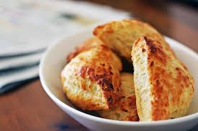

Ingredients:
2 cups all–purpose flour
1 frozen stick butter (4 ounces/eight tablespoons)
1 tablespoon baking powder
1 teaspoon salt
¼ cup milk

Preparation:
Preheat oven to 400° F.

In a large bowl, mix the dry ingredients, then use a box grater to grate the butter into the mix of dry ingredients. Pour in the milk. Stir together very gently with the handle of a wooden spoon (not the spoon part – it’ll be too rough for the batter). Mix it together until it just comes together, adding more milk if necessary – do not over mix it!

Flour a cutting board and roll the dough out in a large circular bun about an inch thick. Cut it pizza–style into eight triangular wedges. Sprinkle the wedges with a little bit of salt and, if you like, some ground black pepper (or even some grated cheese). Bake them in the preheated oven about 10 minutes, or ‘till golden brown and poofy.

