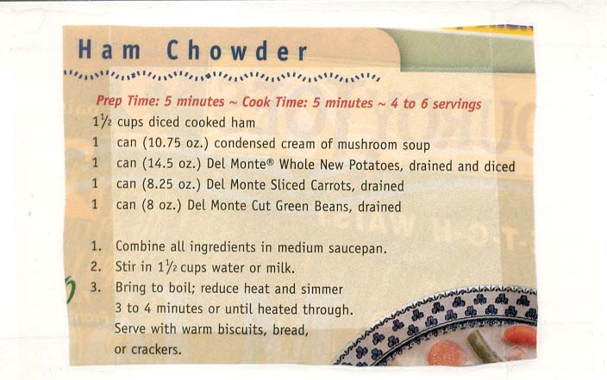
This is really a simple, but delicious soup that can be thrown together in minutes. I dice up an 8-ounce ham steak and, instead of using the canned vegetables in this Del Monte recipe, I dump in three of these cans of Del Monte country-style vegetables & beans:

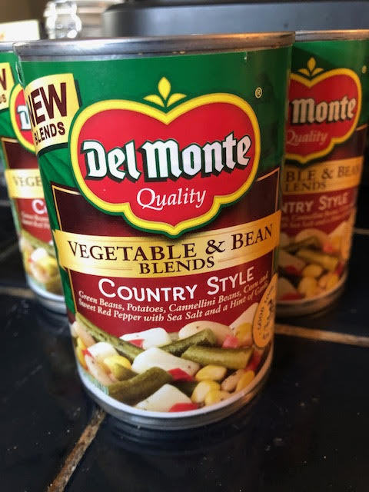

I go with the 1½ cups of milk, but I also add in ½ cup of ham bouillon/broth. I also tip in an 8½ -ounce can of peas and diced carrots. Of course, it needs seasoning (and I also like to sprinkle in some dried Italian herbs). Note that you need a LARGE saucepan for this recipe!

