Fruit Crumble (recipe makes 4 – 6 servings)

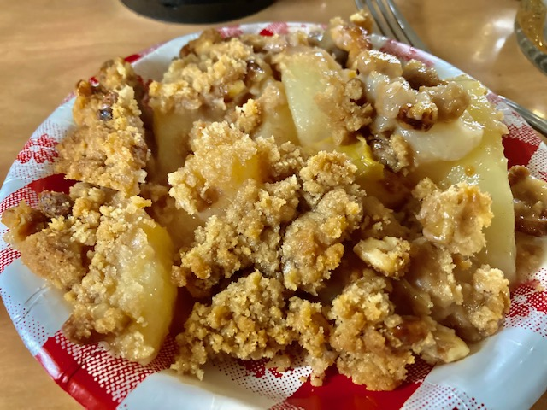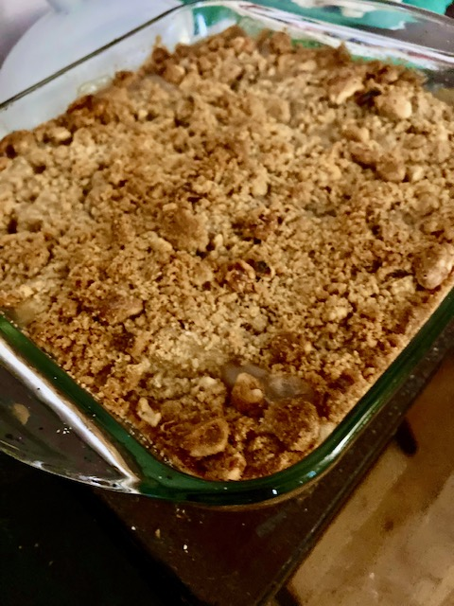

Ingredients:

Filling;
4 large Golden Delicious apples (about 3 pounds), peeled, cored and sliced into ¼” sections, or three, 15-ounce cans of sliced fruit, like pears or peaches, drained
¼ cup sugar
2 tablespoons lemon juice
2 tablespoons all-purpose flour
½ teaspoon ground cinnamon

Crumble Topping:
1 cup walnuts or pecans, roughly chopped (optional)
1 cup all-purpose flour
1¼ cups rolled oats (optional)
½ cup packed brown sugar
1 teaspoon ground cinnamon
1/8 teaspoon salt
8 tablespoons (1 stick) cold butter, cut/sliced into small pieces

Preparation:
Position an oven rack in the center of the oven and preheat to 350 degrees F.

Place apples in a large mixing bowl and toss with sugar, lemon juice, flour, and cinnamon. Pour into a lightly greased 9” x 9” baking dish, and spread out into an even layer. Set aside.

In the same bowl (don’t even bother to clean it out), mix together the nuts, flour, oats, sugar, cinnamon, and salt for the topping. Using your fingers to gently work in the cold butter until pea-sized lumps are formed.

Top fruit mixture evenly with crumble mixture and bake until bubbly and topping is golden brown, about 45 minutes. Serve warm or at room temperature.

