Fruit Cocktail Bread

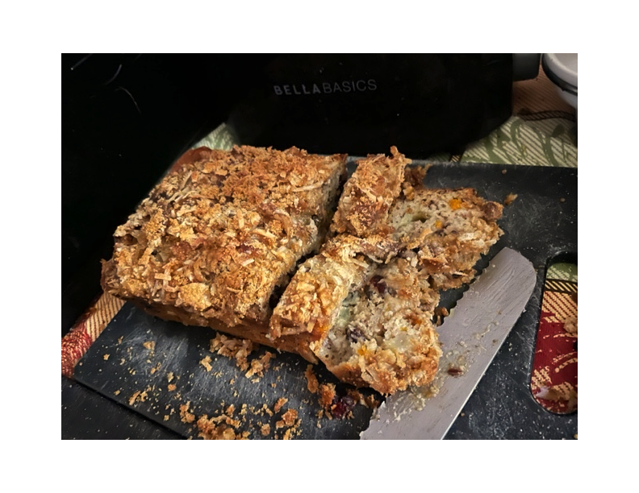

Ingredients:

2 eggs, beaten

1 cup sugar

2 teaspoons baking soda

½ teaspoon salt

1 teaspoon vanilla

½ teaspoon cinnamon

1 can (15 ounces) Fruit Cocktail with juice

1¼ cups all purpose flour

½ cup coconut

½ cup brown sugar

¼ cup powdered sugar

2 – 3 teaspoons milk

Chopped walnuts, to taste

Preparation:

Preheat oven to 350° F. Grease a 9” x 13” loaf pan with butter.

Stir together eggs, sugar, baking soda, salt, vanilla, and cinnamon in a large bowl. Stir in fruit cocktail with the juice, then stir in flour. Pour into prepared pan.

Stir coconut and brown sugar together and sprinkle over the top of the cake. Bake for 25 – 35 minutes or until golden brown and a toothpick comes out mostly clean.

Make the glaze (optional) by whisking powdered sugar and enough milk for a pourable consistency. Drizzle over cake. Serve warm or room temperature. Store loosely covered for up to 2 days.