Southern Fried Cabbage (recipe makes 4 – 6 servings)

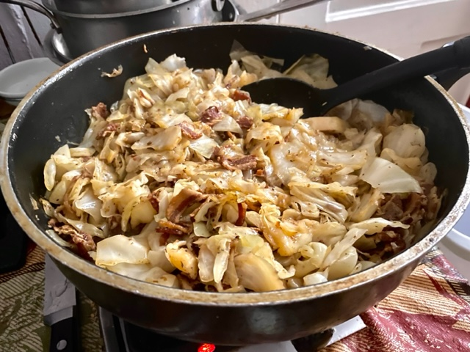

Ingredients:
1 pound diced bacon and/or cubed ham
1 large head green cabbage, cored and sliced/diced (see notes)
¾ cup ham, chicken or vegetable broth
1 tablespoon brown mustard
2 cloves garlic, minced
1 large onion, sliced/diced
Salt and ground, black pepper, to taste
Oil and/or butter

Preparation:
In a large, deep skillet on medium-high heat, brown the bacon – if using ham, add a little oil and/or butter.

Add in and brown the onion and cabbage. Season to taste (I like to add Cajun seasoning or ground cayenne, too). Deglaze with the broth and mustard. Stir well, bring to a boil and simmer, partially covered, on medium-low heat for 10 minutes, or until the cabbage is all wilted and tender and the broth has evaporated (make sure to stir occasionally).

Note:
You can make this recipe with sliced Brussels sprouts!

