French Onion Chicken Casserole for Two

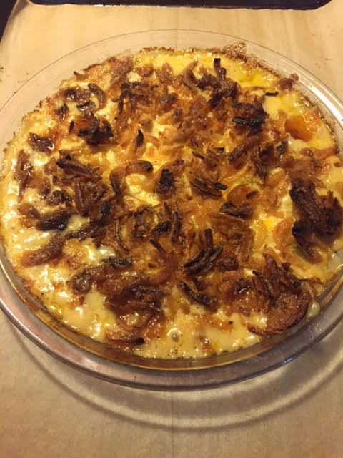

This deliscious dish is an easy way to use up leftover chicken.

Ingredients:
9 – 10 ounces cooked, boneless/skinless chicken, cut into small pieces or shredded
¼ cup slivered or sliced almonds
¼ cup (half a rib) chopped celery
½ cup shredded cheddar cheese
¼ cup mayonnaise
¼ cup sour cream
½ can condensed cream of chicken soup
1 can (2.8-ounce) French fried onions
½ teaspoon ground black pepper

Preparation:
Preheat oven to 350° F.

Mix the chicken, almonds, celery, cheeses, mayonnaise, soup and pepper. Pour the mixture in a pie dish and top evenly with the fried onions. Bake for 25 minutes.

