Golden Flax-Seed “Focaccia” Bread (recipe makes about a dozen slices of “bread”)

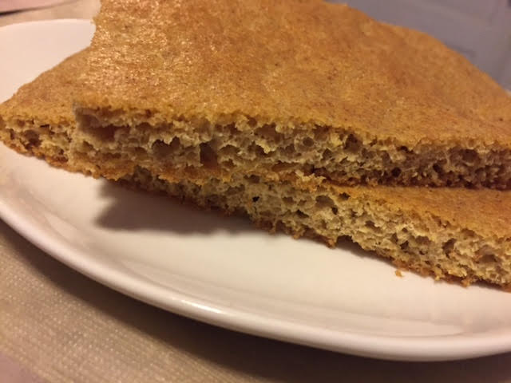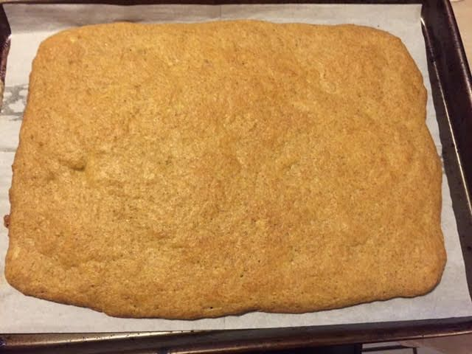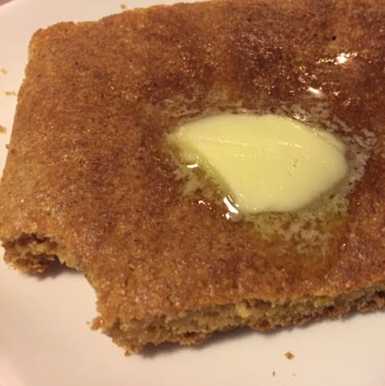

Super easy to make, this is baked flat on a sheet pan, like focaccia, and then cut up into whatever sized pieces you want. It does taste like whole-grain white bread, but it has a really rustic texture. Since it isn't made with wheat, the carb in flax is almost all fiber. It works for toast (toasting it makes it taste slightly like cornbread to me), sandwiches, and other bready uses. Flax is very useful for those on a low-carb diet and it has many amazing health benefits.

Ingredients:
- 2 cups golden flax-seed meal (available at most supermarkets in the baking aisle)
- 1 tablespoon baking powder
- 1 teaspoon salt
- 1 tablespoon sugar equivalent from artificial sweetener
- 5 large eggs, beaten
- ½ cup water
- ⅓ cup vegetable oil, plus enough to grease a baking sheet

Preparation:
Preheat oven to 350° F. Line a baking pan with oiled parchment paper. Whisk together the dry ingredients well. In a separate bowl, thoroughly whisk the eggs with the remaining ingredients – combine the wet and dry ingredients well. Let the batter set for 2 to 3 minutes to thicken up some (but leave it too long, and it gets past the point where it's easy to spread.)

Pour batter onto lined baking sheet. Spread it evenly away from the center and form a rectangle roughly 10” x 14”, about an inch or two from the sides of the sheet.

Bake 24 – 28 minutes, until it springs back when you touch the top and is browning evenly.

Allow to cool completely before cutting into whatever size slices you want.

Nutritional Information: Each of 12 servings has less than a gram of effective carbohydrate (.7 grams to be exact) plus 5 grams fiber, 6 grams protein, and 185 calories.

