Crunchy, Roasted Salt & Vinegar Chickpeas

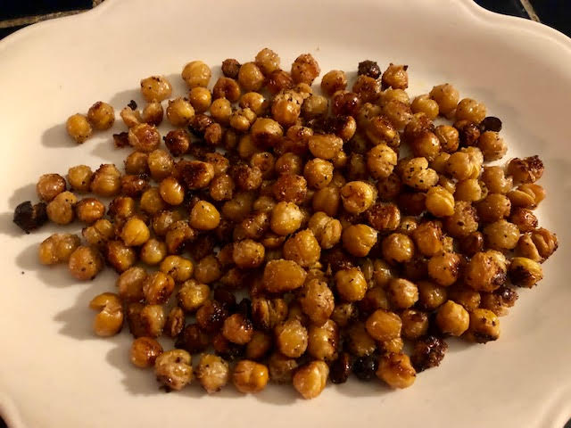

Ingredients:
15 ounces canned chickpeas (also called “garbanzos” and “garbanzo beans”), rinsed and drained
2 cups white vinegar
Salt, to taste
3 tablespoons olive oil

Preparation:
Put the chickpeas, vinegar and a dash of salt into a saucepan and bring to a boil. Remove immediately, once it starts boiling, then let the legumes soak for 40 minutes in the warm vinegar.

Preheat oven to 400° F. After 40 minutes, drain the chickpeas of excess vinegar (save the extra fluid for your next batch, because I promise you’ll be making more – I drain the vinegar into a 16-ounce measuring cup through a very small colander to catch to chickpeas, then just pour it back into its bottle to save it for the next batch).

Spread the chickpeas out on a baking sheet. Coat them with the olive oil and more salt, to taste. You can, of course, also sprinkle on some Creole-spice mix, black pepper, chili powder, garlic powder, ground cumin (whatever you’d like) for an extra kick.

Bake in oven for 35 – 40 minutes, checking every once in a while to stir them around and make sure they’re turning golden brown (not black).

Remove once they’re nice and toasted, and let sit for 10 minutes before munching. They should be crunchy on the outside and a bit soft on the inside.

