Creole Egg Custard (Oeufs aux Lait in French – pronounced “oovs-oh-lay”)

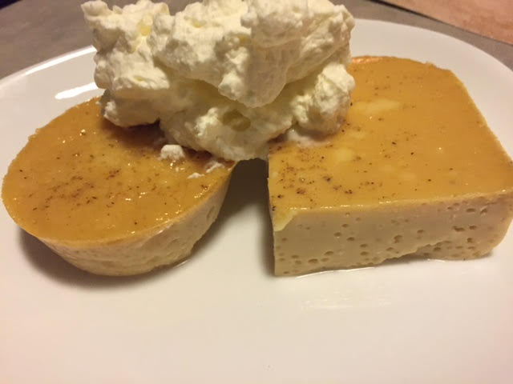

This is an ancient dessert recipe from the Louisiana gulf coast. I can’t remember who gave it to me when I was still living in New Orleans (maybe my dad?).

Ingredients:
6 large eggs, beaten well (you may use 1½ cups egg substitute, if you like)
6, 5-ounce cans evaporated milk (fat-free works great)
1 cup sugar (you may substitute 2 cups Splenda sugar substitue)
2 tablespoons cornstarch
2 tablespoons vanilla extract
⅛ teaspoon nutmeg

Preparation:
Preheat oven to 350° F. In a large bowl, mix all the ingredients well, ensuring that the sugar is thoroughly dissolved.

Grease a 9” x 13” baking dish or 12 muffin baking cups. Fill another pan large enough to set the baking dish or cupcake tray in with 1” water, then set the baking dish/muffin tray in it – this is called a bain marie in the cooking world. Fill the baking dish/muffin cups with the egg mixture, then place the whole thing in the preheated oven. Bake for 25 minutes, checking the water level of the bain marie from time to time and replenishing it as it evaporates away.

After the 25 minutes has lapsed, lower the oven temperature to 325° F. and bake another 30 minutes.

If you made your oeufs aux lait in a baking dish, rather than in muffin tins, let it cool 10 minutes before slicing and serving. Serve the custard either warm or chilled with whipped cream and/or fresh fruit. Any leftovers can be stored in the freezer.

